-

Field Geology

Guidebook and Notes

Illinois State University

2026 Version

Table of Contents

Syllabus 4

Schedule 7

Hazard Recognition Mitigation 8

Geologic Field Notes 16
Reconnaissance Notes
Measuring Stratigraphic Column Notes
Geologic Mapping Notes

Geologic Maps and Mapping 21
Variables affecting the appearance of a geologic map
Techniques to test the quality and accuracy of your map
Common map errors
Official USGS map colors
Rule of V’s

Geologic Cross Sections 25
Basic principles of cross section construction
Apparent dips: correct use of strike and dip data in cross sections
Common cross section errors
Steps in making a topographic profile for a geologic cross section
Constructing geologic cross sections using down-plunge projection

Phanerozoic Stratigraphy of North America 32

Tectonic History of the U.S. Cordillera 36
Regional Cross-sections through Wyoming 40
Wyoming Stratigraphic Nomenclature Chart 41
Rock Sequence in the Bighorn Basin 42
Rock Sequence in the Powder River Basin 43

Black Hills Precambrian Geology 46

Project Descriptions 45
Regional Stratigraphy 45
Amsden Creek Big Game Winter Range 47
South Fork 48
Heart Mountain 50
Bald Mountain 52
Steerhead 53

Appendix 1: Essential Analysis Tools and Techniques for Field Geology 56
Field description of rocks
Measuring stratigraphic sections
Calculating layer thicknesses
Alignment diagram for calculating apparent dip
Calculating strike and dip of a surface from contacts on a map
Calculating outcrop patterns from field observations - constructing a map

Appendix 2: General Guidelines for Map Preparation 75

Appendix 3: General Guidelines for Cross Section Construction 77

Appendix 4: Standard Geologic Symbols and Patterns 79

Appendix 5: Geologic Time Scale 81

Appendix 6: Basic First Aid Advice and Treatment Procedures 85

Emergency contacts 101

GEO 395 – Field Geology
Course Purpose and Objectives

The course is five and a half weeks long, for six credit hours, and is taught on location in northern Wyoming and western South Dakota.

COURSE DATES: May 18 -June 23, 2026.

DEPARTURE: 6:15 AM from Felmley Hall.

FACULTY: Dr. David Malone, Dr. Jed Day and Paul Meister

COURSE OBJECTIVES:
- To learn basic field techniques, particularly: using the Brunton compass, measuring geologic sections, describing rocks, taking field notes, and making field sketches.
- To learn the latest technologies that are used in the construction of geologic maps.
- To learn the skill of geologic mapping, a process that involves total immersion in the science and in the project at hand, and the associated skills of location on topographic maps and air photos and interpretation of features on these.
- To learn to interpret the structure and geologic history of an area based on your field observations and geologic map. Such ability is demonstrated mainly through the construction of geologic cross-sections from the geologic maps.
- To learn the importance of accuracy in data acquisition and placement on a geologic map.
- To integrate aspects of prior coursework into a comprehensive package in which the student becomes aware of the interdependence of all parts of the science of geology.
- To develop an appreciation of the scale of geologic features and of the “reality” of geologic features, as compared to their depiction in print media.
- To develop the skills and expertise needed to make the transition from student to professional geologist.
- To develop senses of self-confidence and professional competence.

ASSIGNMENTS AND GRADING:
A variety of assignments will be given and graded, including, but not limited to, mapping projects from 1 to 4 days duration, cross-section constructions, interpretations of field features, rock and section descriptions and measurements, and a field exam on local stratigraphy. Field notebooks and written assignments also will be critiqued and graded along the way. At the end of camp, the faculty will collectively determine a grade component based on professionalism, work ethic, and attitude that will be worth at least 10% of the final course grade.
All assignments will be due at a specified time, and it is assumed that students will respect the deadlines. Faculty from both universities grade assignments and written comments are made on most projects. Students are expected to learn from critique comments and to improve continuously throughout the course.
Most assignments will have some points allotted to “style and grace”, i.e. neatness and presentation. Correct spelling of all words, particularly geologic terms, is expected.
On most projects, students will work in pairs or small groups. The reasons for this are for safety in the field and for professional discussion of observations and interpretations. However, it is fully expected that each student will acquire his/her own field data, take his/her own notes, and produce his/her own map and cross-sections. It is not acceptable for partners to each do a part of the work and to then exchange information to complete the project. Failure to abide by the above policies may result in dismissal from this course.

RULES:
Adherence to several rules is necessary. More are provided in your field guide.
- There is to be absolutely NO association of alcohol or drugs with University vehicles. Failure to abide by this rule will precipitate dismissal from the course.
- No-smoking rules apply in university vehicles.
- You are not to leave any garbage in the field (GIGO rules!) and not to carve your name, etc. on rocks or trees.
- You are to leave gates as you find them, open or closed, and you are not to climb wire fences.
- Do not walk across alfalfa or hay fields.
- Vehicles leave for the field promptly at 8:00 AM. Be there and be ready or be left behind.
- You are reminded of the ISU student code of conduct. Prior to your departure, you will be asked to sign an agreement as to how you will be expected to conduct yourselves while we are working an on the days off.

WORKING CONDITIONS:
The working conditions in the field can be both physically and mentally taxing. You may walk ten miles in a single day, climb 2000 ft in elevation and spend all day above 9000 ft. Keep yourself in top working condition and keep a positive attitude. Wear a hat to protect yourself from the sun. Drink adequate water to prevent dehydration and eat balanced meals. You need electrolytes and carbohydrates. This is not a time to be dieting.
A tentative schedule will be issued that provides for a six-day workweek. One day per week is scheduled off. However, because of unpredictable weather conditions, it is often necessary to shuffle the schedule. No scheduled day off is guaranteed. It is important to note that most evenings will be working too, as lectures and project work will occur during these times.
Weather conditions over the six weeks are likely to vary between cold, wet and snowy with temperatures barely above freezing, to hot and dry, with temperatures in the lower 100’s. Particularly during the first half of the course the weather can be truly nasty. If at all possible, we work rain or shine, so always be prepared with adequate clothing and rain gear. Prepare to dress in layers, as the conditions often vary widely within a single day.
You will be working on steep slopes, some with loose rock. Always be cautious with your footing and be aware of people below you. If you loosen a rock on a slope, yell “ROCK!” loudly to warn those below.
Some critters and plants can present dangers in the field. Rattlesnakes are common, particularly in the outer edges of the Black Hills. If you hear their warning, let them be and go around them. Warn others of the snake’s location. Do not try to kill them. Be careful stepping or reaching where you cannot see. Deer ticks may carry Lyme disease and wood ticks may carry Rocky Mountain spotted fever. You should make a “tick check” every night.
Be wary of cattle, some are friendly, some are not. They are curious creatures and like to follow you around.
Poison ivy is extensive in some areas, especially prevalent on limestone and dolomite. Learn to recognize it. Ask faculty to point it out until you learn.
Alcohol and smoking retard your ability to function efficiently in the field.
We will work on private and public property. Respect it and leave no trace of your presence.
After the rainy season, forest fires are a very real hazard. It is best not to smoke in the field. If you must, then sit down in one place to smoke. It is not acceptable to be walking around smoking. Cigarette butts are to be ground out, then field stripped before being released. That means you must use your fingers to strip the paper and physically disaggregate the tobacco (if it is too hot to do this, it is too hot to put down), then grind the remains into the ground.

MISCELLANEOUS COMMENTS:
Cell coverage varies, and is spotty at each of the places that we stay.
Sturdy field boots are required. Tennis/running shoes are not acceptable.
You will be staying in dormitory rooms. Students from all schools will be paired, but not males and females together. Rooms are Spartan (beds, mattress, closet, desk, dresser, chair, wastebasket, four walls, ceiling, door and a window. There is Wifi in Sheridan and Spearfish, but not the two destinations in Wyoming. Bedding and pillows are not provided everywhere but Spearfish (still working on that). Bringing a small sleeping bag is recommended.
If you maintain a positive attitude and an open mind, and if you try your best, you will most likely learn more in this course than in any other course you have ever taken and will enjoy doing so. Alumni say they will remember it fondly the rest of their lives. This course ties together most of the geology courses you have taken in preparation for being here and prepares you to enter the professional world.
Laundry facilities are available at most of the places that we stay.

Things to Bring
Geology Equipment
pocket knife
hand lens, approx. 10X
geology hammer
at least two one-liter water bottles
calculator, with trig functions
day pack
protractor-ruler (6”)
pencils
drawing pens
colored pencils
erasers

Personal Stuff
Bedding (sleeping bag) & pillow
Clothes for about a week. Avoid cotton for the field clothes.
medications
towels
swimsuit
hat
field boots (Vibram soles are best) & socks
insect repellent and sunscreen
field clothes, including gloves
sunscreen
rain gear
cold-weather jacket or coat
toiletries

Tentative Schedule
17-May | 18-May | 19-May | 20-May | 21-May | 22-May | 23-May
Arrive ISU | Chamberlain | Badlands | Bighorns Recon | Cambrian | Paleozoic | Mesozoic
24-May | 25-May | 26-May | 27-May | 28-May | 29-May | 30-May
Draft  Mapping | Off  Sections | Amsden | Amsden | Amsden  Amsden | Draft | Off
31-Jun | 1-Jun | 2-Jun | 3-Jun | 4-Jun | 5-Jun | 6-Jun
SFS Recon | SFS | SFS | SFS | Draft | Off | HMD Recon
7-June | 8-June | 9-Jun | 10-Jun | 11-Jun | 12-Jun | 13-Jun
HMD | HMD | HMD | HMD | Draft | Off | Steer
14-Jun | 15-Jun | 16-Jun | 17-Jun | 18-Jun | 19-Jun | 20-Jun
Steer | Steer | Draft | Bald | Bald | Draft | Caribou
21-June | 22-June | 23-June | 24-June | 25-June | 26-June | 27-June
Caribou | Albert Lea | Arrive ISU

How Friends and Family Can mail you things.
Below are the addresses and phone numbers at which you can be contacted. Note that while at field camp you can receive mail at any location where we will be staying for more than a week. We do not recommend that anyone try and send you mail at any of our other locations because it is highly unlikely you will receive it while we are there, and it is difficult if not impossible to track down letters or packages that might arrive after we depart from one of our "base camps." For our Sheridan and Cody destinations, internet access and cell coverage will be limited while we are in the field. You should have good cell coverage as we drive to and from field areas, but the evening accommodations and field sites will have limited coverage. Please plan accordingly.

Sheridan College
3059 Coffeen Avenue
Sheridan, WY 82801
(307) 674-6446

https://www.ddxranchwyoming.com/

SOME THINGS TO REMEMBER

1. Up the mountain!

2. It is a marathon!

3. Get better every day!

4. The first thing you do when you look at the rock is look at the rock!

5. Don’t worry about what doesn’t matter!

6. Help other folks when then need it. Keep an eye on them!

7. Keep a positive attitude. Yesterday is gone. Tomorrow is the best day of your life!

Environmental Hazards

Considerations
- Field camp activities occur at elevations ranging from 4,000 to 10,000 ft (1,500 to 3,000 m). The reduced amount of oxygen at altitude may adversely affect pre-existing medical conditions. Symptoms such as shortness of breath and rapid pulse may develop. Blood pressure may increase transiently, and some may develop swelling in their feet and ankles.
- Expect a wide range of temperatures. Typical daytime temperatures range from ~50 to 90 °F (10 to 32 °C). Evenings are generally mild, but be prepared for nighttime temperatures from 30 to 50 °F. In a single day the weather can go from sunny and warm to a blizzard. BE PREPARED FOR THE UNEXPECTED!
- Dehydration develops quickly at field camp because of the very low relative humidity and intense sunshine.
- The thinner atmosphere at high altitude filters less UV light and thus predisposes one to sunburn. Similarly, the sun is very bright in the mountains so bring a good pair of sunglasses.
- High winds can occur. Be prepared with a suitable windbreaker... wind can be exhausting and annoying for the unprepared.
- Intense snow and thunderstorms are possible, again be prepared for the unexpected.
- Vegetation will vary from mountain forests to desert terrain at Alkali. Be aware of your surroundings at all time.

Associated Safety Hazards
- Altitude sickness is a syndrome with potentially incapacitating symptoms. Although it generally only occurs when one sleeps at altitude above 8,000 ft (2,500 m), students may develop symptoms. Frequent symptoms are headaches, nausea, insomnia, extreme fatigue, listlessness, lack of appetite, and light-headedness. Generally, symptoms will improve with rest and fluids in 24 to 48 hours. Report any persistent symptoms to the Director. Alcohol, tranquilizers, sleep medication, and antihistamines may make altitude sickness worse.
- Dehydration can cause fatigue, severe headaches, and result in heat exhaustion & sunstroke.
- Exposure can result in sunburn, windburn, cold-related illness (hypothermia & frostbite), heat-related illness (heat exhaustion & sunstroke), and snow blindness (sunburn of the eyes).

Mitigation of Hazards
- To prevent altitude sickness and dehydration, always drink enough water to cause the need for urination at least every three hours while at camp. While in the field, students should drink a minimum of two to three liters of water per day. Drink small amounts of water at a time throughout the day. Hydration packs (e.g., Camelbacks) are great investments.
- Sunburn and heat exhaustion are common and unnecessary camp ailments. Sun block is mandatory for those with sensitive skin and should be used by all. People who do not usually burn are more apt to get caught because they do not take necessary precautions. Wear wide-brimmed hats, pants, and light shirts to keep cool and prevent sunburn.
- Wearing UV filtering sunglasses will protect your eyes from snow blindness. Contact lenses can be troublesome in the field because of dust and low humidity. If you prefer contact lenses, bring lots of lens solution and a backup pair of glasses. It is important to wear eye protection (glasses, goggles, sunglasses, etc.) in the field to protect your eyes when you (or those around you) are breaking rocks.

Health Hazards

Considerations
- Field camp is physically challenging, and students must be prepared for a rigorous field experience. You will be conducting physically demanding field exercises, including considerable hiking at high elevations. Students in good physical condition are able to complete the course without difficulty. However, the performance of students in poor physical health or condition could be hindered by an inability to access portions of field project areas. Field camp is a physically demanding and may not be right for everyone.
- Venomous rattlesnakes are common at lower elevations, but they are timid, avoid people, and rarely bite. Mountain lions and bears have been seen in some of the field areas in the past. Moose are commonly encountered in the alpine meadows of our field areas. These are large and sometimes dangerous animals. Do not enter an area occupied by moose. All animals should be left alone – harassing any animal could result in your dismissal. Do not feed any animal, either intentionally or through your own inaction.
- Stinging insects such as hornets, wasps and bees are present. Ticks are common at lower elevations.

Associated Safety Hazards
- Poor physical conditioning may lead to overexertion and severe fatigue that can exacerbate pre-existing medical conditions and contribute to accidents. Participants in poor physical health or condition and those with serious medical conditions must check with their physician prior to attending this camp.
- You may have allergic reactions to insect bites or plant puncture wounds.
- Burrowed ticks can cause infection or spotted fever.

Mitigation of Hazards
- Please consult your physician before considering attending camp – especially if you have a history of cardiac or pulmonary problems, physical, emotional, or mental conditions. In such cases, a physician’s permission may be required prior to acceptance. We urge you to have thorough and complete medical and dental checkups before field camp. Minor complaints will be amplified under the stresses of heat, altitude, and hard work at camp. These issues should be taken care of in advance. You should have shots for tetanus if not currently protected.
- Participants should determine their ability to handle the short periods (20 - 60 min) of strenuous exertion at relatively high altitudes required to access some of the field areas. Vertical changes in elevation are generally on the order of 800 ft (250 m) or less at base elevations of 5,000 to 10,000 ft (1,500 to 3,000 m). The importance of beginning daily cardiovascular exercise at least one month prior to departure cannot be stressed enough.
- Fully disclose all regular medications (prescription and OTC) in the Personal Medical Assessment form and notify the Director(s) of any special medications you may be taking before any emergency situation arises.
- Fully disclose all known dangerous allergies (e.g., insect bites, foods, etc.) in the Personal Medical Assessment form. Bring any medicines or antidotes (epi-pens) that you might require. To ensure you receive appropriate care in the event of an emergency, personally bring your allergies to the attention of the Director(s) on the first day of camp (so we can associate your face with the form).
- Health insurance is required. You are responsible for all medical and dental expenses while at camp – the camp has no responsibility for the medical expenses of students and does not provide students with any forms of medical insurance. Work closely with your family and your university to determine what health insurance policies are available to you and what the limits of your coverage are before coming to camp. Make sure to carry your medical insurance information with you at all times.
- Use insect repellant and check yourself carefully for ticks each day.
- Your chances of being bitten by a snake become remote when wearing sturdy, over-ankle boots and by not putting your hands (or any other part of your body) in places you cannot see. Leave the snakes alone – a little fear is a very healthy thing. If you should be bitten, make sure the snake was a rattlesnake before doing anything. If it was a rattlesnake: (1) Slow down circulation and be as inactive as possible. If possible, don't run or walk, and have someone assist you to a vehicle. Allow the wound to bleed freely. (2) Have someone get you to a doctor as soon as possible. Make sure the doctor checks for reaction to horse-serum, if necessary.

Activity Hazards

Considerations
- Expect daily hikes in the field areas that cover several miles and up to 1000 ft (300 m) of relief.
- Hikes typically cross rough, steep, and/or unstable terrain. Good judgment and extreme care for yourself and those around you are critical. Many people have been injured (some seriously) or even killed (fortunately, not our students) wandering through the areas we work in.
- Unsafe cliffs, overhangs, and steep slopes are common in field areas. Stay away from these hazards and be aware of the people above and below you. A former student broke both legs in an accident when another student unintentionally kicked loose a boulder. She also required an airlift.
- Many students have limited experience working in the outdoors and with the tools of a field geologist. Misuse of field gear (e.g., hammers, bruntons, GPS units, etc.) may create unexpected hazards. When used improperly, personal gear may provide less than optimal protection from the elements (e.g., improperly laced boots, hats in backpacks instead of on head, etc.).
- The most serious injuries at field camps do not occur in the field where geologists are all generally fully aware. On the contrary, most serious injuries occur when students are relaxing: playing ultimate Frisbee, soccer, mountain biking or even walking home from “an evening out”.
- Reckless behavior in the field (running and jumping over gullies, wandering away from the group, etc.) or at camp (roughhousing) that compromises the safety of yourself or the others on the trip will not be tolerated and could result in dismissal from camp.

Associated Safety Hazards
- Trip and fall hazards are extremely common, especially along ledges and steep slopes. Loose rocks and overhanging rocks exist on hillsides and trails. Remember that an injury to your knees, back, etc. could seriously limit or end your career as a field geologist, certainly for the summer.
- Inadequate footwear commonly results in a range of avoidable injuries, including puncture wounds (from thorny brush, cactus spines, and sharp rocks), severe ankle injuries, and slips and falls.
- Improper use of hammers and/or chisels can result in serious injury to yourself or those around you. Common injuries include crushing wounds and metal shards and/or rock chips in eyes.
- Reckless behavior creates a wide range of completely avoidable hazards.

Mitigation of Hazards
- While each person is primarily responsible for his or her own safe conduct, they must also contribute to the welfare of the entire group. In each field area, the leaders will brief participants on expected and potential hazardous situations and conditions.
- If you are not comfortable participating in any of the particular activities for any reason, you are encouraged to notify an instructor. There are no negative implications for this decision.
- Sturdy, close-toed boots are required in the field at all times. Boots with Vibram-type soles, good tread and sturdy leather (or similar) uppers provide excellent protection against injury. Participants without adequate hiking footwear will not be allowed to enter field sites and will be barred from participating in some activities. For example, Newmont Mining Corp requires boots and long pants at all times. Please contact an instructor, ideally before camp begins, if you have any questions regarding the field boot policy.
- Long pants are recommended in the field
- When breaking rocks, move away from others and turn your back towards them. Always warn those around you when plan to use your hammer! Never use another hammer as a chisel. Always protect your eyes with some form of safety glasses (e.g., shatter resistant sunglasses). Once again – an injury to your eyes (and those of your classmates) that could seriously limit a career in geology.
- Please be careful when not in the field. When relaxing, remember that you’ve been working hard and are probably more tired than you realize. You have spent a lot of time and money to get to this stage of your geological education - don't screw it up with a careless injury that prevents you from completing the course.
- Reckless behavior is unacceptable. If your behavior becomes a significant problem, you may be dismissed from Field Camp and will be responsible for your own trip home.

Transportation Hazards

Considerations
- Thousands of freeway and off-road miles are put on vehicles at camp each summer. Drivers have a great responsibility BLS and must be extremely vigilant and careful – the lives of all of passengers, members of the caravan, and the public at large are in their hands.

Associated Safety Hazards
- Driver-related hazards are significant and include fatigue, distractions, and inattention during driving.
- Car-person collisions are a serious hazard during activities that require work along busy roadways.
- Flat tires introduce significant hazards associated with both the operation of a moving vehicle and roadside repairs.

Mitigation of Hazards
- All participants must pay careful attention to safety briefings by the instructors. It is your responsibility to be fully informed of potentially hazardous conditions associated with use of vehicles.
- Passengers must never do anything to interfere with the driver's ability to operate the vehicle safely.
- Passengers riding shotgun should never sleep and should help keep drivers awake and aware.
- Personnel driving university vehicles must have completed ISU’s van driver training.
- Before driving, drivers should take whatever time needed to familiarize themselves with their vehicle and routes.
- Participants must wear high-visibility clothing (and/or safety vests if provided) when working along roadways and bike trails.
- Read, understand, and follow the procedures in the Guidelines for Driving University Vehicles.

Guidelines for Driving University Vehicles
The following guidelines regarding the use of university vehicles must be read, understand, and followed at all times:

For All Vehicle Occupants
- Safety restraints (seat belts, both lap and shoulder) must be worn by everyone whenever a vehicle is in motion.
- Keep Vehicles Clean. Regularly remove trash. Loose bottles, rocks and materials on the floor are significant hazards to safe vehicle operation. Whenever possible, maintain the driver’s ability to see out of the rear window when packing the vehicles.
- Hazardous materials (e.g. flammables, corrosives, explosives, compressed gases, etc.) must not be transported in a university vehicle.
- Alcohol consumption in any university vehicle is strictly prohibited.

For Drivers
- Authorized drivers are individuals cleared to drive specified vehicles by a university’s department of risk management. Drivers must immediately inform field camp and their home university if they receive a suspension, probation, cancellation, or disqualification of his/her driver's license.
- Authorized drivers are subject to all traffic laws and are financially responsible for any traffic citations. In addition to posted limits, drivers must operate at speeds suitable for vehicle, road, traffic, and weather conditions. Where vision is restricted, drivers must slow to a speed that will permit the safe negotiation of curves, hills, or intersections.
- Driver fatigue is a leading cause of fatal accidents. Requests for breaks or driver swaps have priority over any itinerary.
- Keep to the right on highways. Do not linger in the fast lane – use it only to pass.
- Do not pass the lead vehicle. Unless safety dictates otherwise, maintain your position in the line of vehicles. Do not worry about “keeping up” with the vehicle ahead of you – instead, slow your vehicle to maintain visual contact with the vehicle behind you.
- Avoid distractions. The use of cellular telephones and iPods, etc. while driving are not permitted (even with a “hands-free” device), except in immediate emergency situations.
- Drivers are responsible for thoroughly inspecting their vehicle prior to initial use and regularly thereafter for unsafe conditions or damage. Drivers must immediately report vehicles that are damaged or in an unsafe condition.
- If you experience a flat tire or other vehicle malfunction that requires leaving the roadway, pull to the right shoulder – never stop in the center median. Carefully pull off as far as possible, but do not go over the shoulder. If possible, park on a hard (paved) surface.
- Accidents involving any vehicle (university or private) during field camp must be reported according to relevant accident reporting guidelines. The camp director must be notified immediately.
- Use of university vehicles while under the influence of alcohol or drugs (including prescription drugs that may impair the ability of the driver) is prohibited.
Geological Field Notes
Taking good field notes is an integral part of geologic mapping and field work. Your field notebook is among the most important pieces of equipment you take with you every day and it should be useful to other geologists who are not familiar with the area in which you are working. Good notes are legible, organized, detailed, and informative. The organization of your notes will determine how accessible they are to other geologists. If another geologist cannot understand what you are writing about, where you are working, how your data are recorded, what led you to interpret your data the way you did, or why you are conducting this study in the first place, then your notes are essentially useless to anyone but you.
In the inside cover of your notebook you should list your name, employer, and complete contact information. A table of contents that lists each project should also be included in the first page of your notebook. Be sure to update the as you progress through this course. Remember to continually update notes as needed; NEVER expect to complete your notes after you have left the field area at the end of the day. You will record three distinctly different types of field notes during your time at Field Camp. These include: reconnaissance notes, stratigraphic column notes, and geologic mapping notes. Each of these has its own unique style but involve much of the same information. Examples of each of type of notes are provided on the final three pages of this section.

1. Reconnaissance Notes
These are notes taken during local or regional reconnaissance of a field area. They are a log of all the stops you make and a record of your observations and interpretations that will be referenced later as you conduct more detailed work in that area. Good reconnaissance notes can be a great help in understanding the details of a smaller area of study in that region. Reconnaissance notes should contain information in each of the following subject areas.

Date: Record the date at the beginning of each day. Each day of vanology notes must begin on a new page.
Purpose: This is a sentence or two addressing the reason for conducting this reconnaissance.
Weather: Record the weather at the beginning of the day and note changes as the day progresses. Rocks look different on wet cloudy days than they do on dry sunny days.
Stop Number: (these are simply numbered)
Time: Record this for each stop.
Location: May include road names, mile markers, distance from nearby towns, grid system coordinates or other forms of location identification. Someone else should be able to find this stop using your notes. You should be paying attention to where you are when we travel so you gain a better understanding of how one stop is geographically and geologically related to the next.
Purpose: Explains the reason you are making each particular stop. It could be to get a regional overview, to describe a road cut, or some other specific reason. This can be as short as a single sentence. Example: To describe outcrop along road which is representative of Cambrian stata in the region.
Observations and Data: This can take many forms; outcrop and hand sample description, structural data, stratigraphic columns, and sketches. This is the most important part of your notes and must be as detailed, organized, and legible as possible.
Interpretation: This is separated from your data and is YOUR explanation of what you’re looking at, how it got there, and its significance. These are always open to debate whereas your data is not.

Reconnaissance Note Grading – scores will be bases on: organization, outcrop/hand sample descriptions, sketches, and style and grace (including penmanship).

2. Measuring Stratigraphic Column Notes
These notes include a scaled sketch of a section with notes describing the material and may include your interpretations.

Date: Record the date at the beginning of each day.
Location: This should be specific. Measured sections can vary greatly in a short distance.
Partner: Record the names of all those you are directly working with.
Purpose: This is a sentence or two addressing the reason for creating this column.
Weather: Record the weather at the beginning of the day and note changes as the day progresses.
Methodology: Document the method you will use to measure the section and any formulas you will use for calculating thicknesses. Include eye height and pace if used.
Observations and Data: (See example) this will include a scaled sketched column with weathering profile, formation/unit names, geologic time labels, structural data if acquired, descriptions, and interpretations. Include published geologic patterns in sketch. When creating your own original patterns, include an explanation of that pattern.

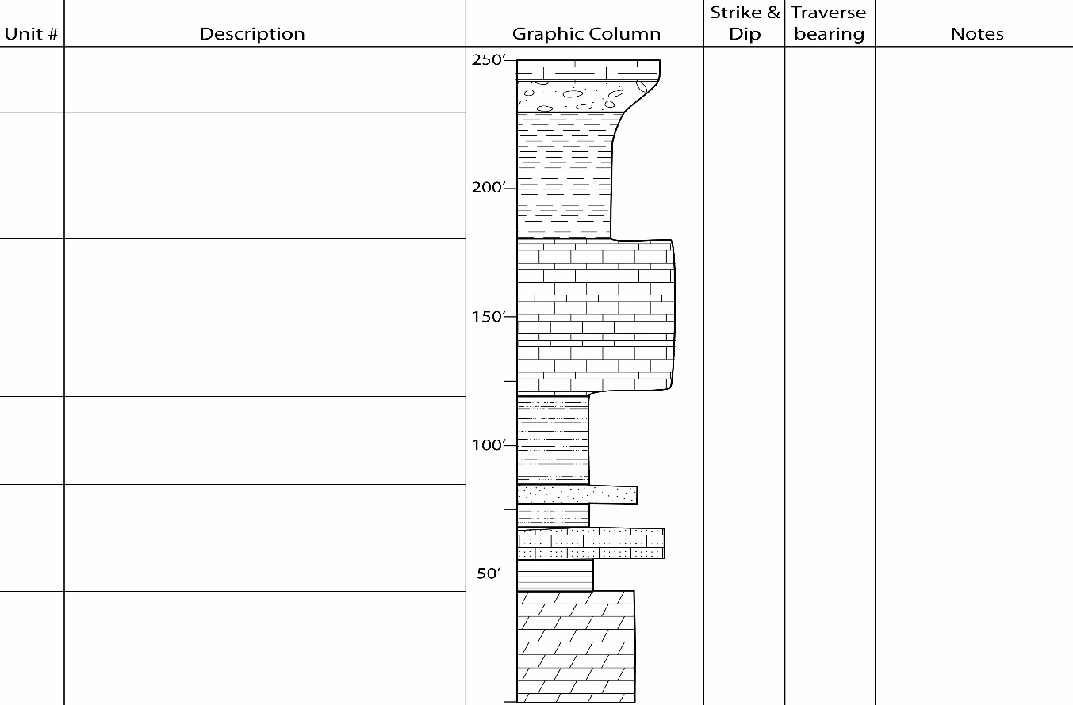
Stratigraphic Column Grading – scores will be based on: organization, column sketch and labeling, descriptions, and style and grace.

Binding of field notebook
Example layout of your field notebook when measuring stratigraphic sections.
(eg., strike &dip, traverse bearing,
Obstacles or complications in traverse

3. Geologic Mapping Notes
These notes document everything needed to complete a geologic map and cross section. They are a record of where you were, what you saw, and your interpretations. They include location information, traverse direction, structural data – in textual and tabular format, sketches, outcrop and hand sample descriptions, and interpretations. Although you will document data on a topographic base map, anyone should be able to recreate the geologic map using your field notes.

Part A
Introduction – this part begins each mapping project and sets the stage for the entire multi-day project. The introduction will be on the first page of each mapping project and should be setup before entering the field.

The introduction includes;
Title: For the project, example: Geologic Mapping of the Clear Creek Thrust near Buffalo, WY. Location: The location of the project which can be directly copied from the final map you will be given.
Partner: You will be assigned a different partner for each project. We do this for safety reasons. You will be expected to collect your own data.
Purpose: This is a couple of sentence addressing the reason for this project.
Benchmarks: (if used) Document the benchmarks you may use for field station location in this area. Benchmarks can be a variety of things including: road intersections, UTM gridline intersections, Township and Range gridline intersections, or X’s at hill tops. You may need multiple benchmarks to cover the map area. All should be identified and documented prior to entering the field.

Part B – this part must be done for each day of mapping.

Date: Record the date at the beginning of each day.
Weather: Record the weather at the beginning of each day and note changes as the day progresses.
Location: This is the specific region of the mapping area you will work be working during this day.
Purpose: This is the purpose specific for each day.
Data: (see example) this is a record of everything you see, do, and think. This is where organization is crucial. These notes should read like a book, telling the story of everything you see, do, and think, both texturally and graphically. Data includes:

Field stations: You will assign a field station ID at each place you collect data. This is a combination of letters and sequential numbers. Example: CC01

Locations: All field stations locations will be recorded with a distance and bearing from one of your predetermined benchmarks.

Traverse: Record the direction you will travel as you leave a field station and why you are going that way. This is just a sentence letting the reader know where you are going and why. For instance: Walking ~SW from CC23 toward 6530 hill looking for change in soil color which would indicate a change in mapping units.

Descriptions: You will be describing a variety of things in the field. Outcrop description will consist of size of exposure, bedding thickness and orientation, weathering profiles, color, etc.
Hand samples must be systematically described just as they are in sedimentology, mineralogy, or petrology. When approaching a new outcrop, first describe the outcrop. This gives the reader a mental image of what you are looking at and sets the stage for hand sample description. You may also be describing offset along faults, changes in soil color and texture, and change in vegetation. All measurement for a project must adhere to the same measurement system. This means, if you start with the metric system stay with it for the entire project. This applies at all scales and includes sketches.

Sketches: These are an important part of your notes and visually support your textual notes. Following are the standards you will need to follow.
- Orientation – Sketches are oriented either top is toward the top of the notebook or top is to the front cover. (see examples)
- Labels – each sketch must have a title indicating whether the sketch is map view or cross-sectional view. Include N, S, E, or W directional labels.
- Explanation – each sketch needs a textual description indicating the significance of the drawing.
- Dimensions – label both vertical and horizontal distances on cross sections and map distance on map views.
- Other things – you may find it appropriate to label mapping units, structural data, or fault slip directions directly on the sketch.

Structural data: Structural data must be recorded both in your textual notes and in the structural data table.

Interpretations: Your interpretations must be separate from your observations. These will be revisited as you begin creating your finished geologic map and help you remember what you were thinking as collected data at a field station. They also will help a reader of your field notes get a better understanding of what you think occurred in an area. They might include your thoughts on the depositional environment, sense of deformation, relative age between units, or anything else you may want the reader to understand about what you see and think. Keep in mind, these are always open to debate and need not be accurate. You may refine or change your interpretations as the project progresses. Your interpretations are unlikely to be “right” the first time. Strive to correctly record how things “are,” and then develop multiple hypotheses to explain the geology you observe.

In general, you should never erase any hypotheses or interpretations you enter in your notebook. Use it as a running log of your daily ideas and struggles. Who knows, on the third day of mapping you may uncover new data that supports an interpretive cross section you made on day one, but that you thought was crazy on day two!

Taking and maintaining good field through the duration of a project is hard. Developing good field note taking habits not only will help you with the activities here at field camp, they also help you organized your observations make you a more competent scientist.

Geologic Mapping Notebook Grading – scores will be based on: organization, note quality, sketches, rock descriptions, and style and grace.

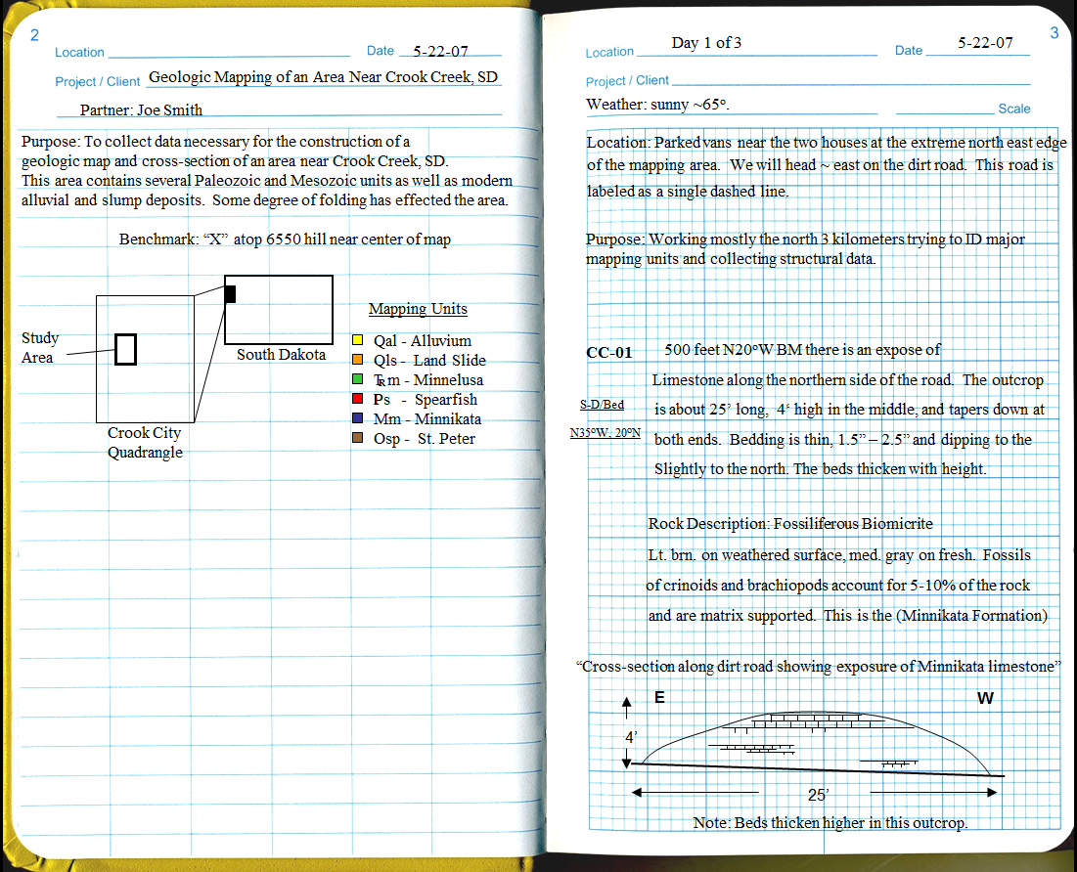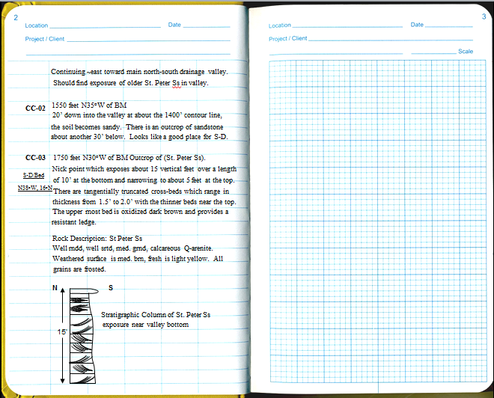
Geological Maps and Mapping

The objective of geologic mapping is to produce a map that shows the surface distribution of rock units, with contacts drawn between them, and sufficient structural data to construct cross sections illustrating the structure.
You will have two copies of the map you are making, a field map and an office map. The field map is a work copy and is done in pencil. Although you should strive to keep it neat, it is not expected to be immaculate. Instructors will periodically collect and grade your field map. The office map is your insurance policy. Every night when you return from the field, you should transfer data and contacts from your field map to your office map. Instructors will not check to make sure you have an office map, but, if it rains all over your field map on the next to last day of mapping and you lose all your data for the previous two days, you'll be sorry you didn't keep an office map.
The following are some general comments, guidelines and rules regarding maps and mapping.

• Keep track of yourself on the topographic map at all times. Know the scale of the map, the contour interval and how to triangulate to locate yourself in problem areas.
• All mapping is to be done in the field, including placement of contacts and plotting of structural data. This means that strikes and dips are to be plotted on the map in their correct location and orientation at the time they are measured. This is important because, 1) it allows you to recognize inconsistent data when you can still correct it, and 2) it allows you to see the structure developing, so you can plan a logical strategy for continued mapping. This is the most difficult thing the faculty have to convince students to do and why we often collect field maps unannounced.
• Field stations should be accurately located and marked on the map. Your field notes for each station should be identified by the station number and should include the GPS coordinates and/or a brief geographic and geologic description of the station location.
• Contacts: Solid lines for contacts located within the spacing of one contour interval, dashed lines for less accurately located contacts and dotted lines for contacts covered by other units, such as by Qal or Tg.
• Contacts between sedimentary rocks do not normally meet or truncate one another, unless there is an angular unconformity. Sedimentary rock contacts usually can be projected logically as a mapping strategy.
• Contacts of igneous bodies commonly are irregular and truncate other contacts. They must be “walked out” or followed carefully in the field.
• Qal (Quaternary alluvium) refers to Recent stream deposits. These are flat-lying, so contacts should closely parallel contour lines. There is no Qal on hill slopes. Qal should not be used to hide contacts, instead contacts beneath Qal should be dotted or concealed.
• Be aware of the “Rule of V’s”. Unless formations are vertical, contacts must obey the Rule of V’s when crossing topography. In general, a contact will "V" in the direction of younger rocks, unless beds are overturned. (See figure on the following pages.)
• Be aware of “strike ridges”, those that follow the strike of bedding. Be suspicious of plotted strikes that are not parallel to strike ridges and contacts that cross strike ridges.

• Do not place contacts along the crests of ridges. Linear topographic ridges, or hogbacks, are often held up by a resistant unit, the base of which is some distance below the crest. The contact making the base of the resistant unit is commonly at the base of the ridge. Contacts can easily be projected along hogbacks.
• Strikes and dips: Bedding plane surfaces commonly are irregular at a given outcrop. When taking S&D measurements, survey the outcrop and select a place where the attitude is representative of the overall trend at the outcrop. A sufficient number of S&D’s should be plotted to determine the structure of the area, no matter where you are asked to draw a cross section.
• Spacing of strikes and dips: If S&D is consistent for a considerable distance, then you need not record them very close together. However, if the attitude changes rapidly, then S&D must be recorded with a closer spacing. You can’t have too many structure data.
• Coloring: As you traverse an area of the map, color it in lightly for the appropriate rock unit; this gives you some perspective on how much has been accomplished and how much remains to be done.
• Field sketches: As you piece together the structure, make interpretive, labeled sketches of the map (or cross sections) in your notebook. This should help you to interpret the geologic history, to figure out the strategy for completing the project and to make cross sections later.

Variables Affecting the Appearance of a Geologic Map
Outcrop patterns of sedimentary and metasedimentary rocks are a function of relatively few variables. Having a firm grasp of the general influence of each of these variables will be a great help when you are mapping because it will allow you to qualitatively or quantitatively check your map for common errors and inconsistencies. The general variables affecting the outcrop pattern of any planar feature are:
1. formation thickness
2. formation strike and dip
3. surface topography
Remember that just like contacts between formations, faults are also planar features which are affected by these variables. You should be able to infer the general strike and dip and thickness of a layer from its map pattern. Conversely, when you are mapping, if you know the formation thickness and strike and dip, you should be able to estimate or predict the general outcrop pattern for any planar feature.
All bets are off when you are mapping igneous rocks or any feature that is not curviplanar in 3-D. These features can have highly irregular outcrop patterns that are totally unpredictable!

Techniques to Test the Quality and Accuracy of Your Map
If you are unsure about the placement of contacts on your map, there are several tools you can use to ensure you placed your contact reasonably. These tools include:
1. calculate the formation strike and dip from your map pattern and compare it with the strike and dip data you collected – they should match!
2. use three locations where you are certain of a contact to construct an outcrop pattern over the topography of the problematic region
3. calculate the formation thickness from your outcrop pattern – it must be close to the known thickness of the formation!
Note that these approaches only work if the rocks are homoclinally dipping throughout the area in question. If there are abrupt, significant changes in strike and dip over the region in which you are trying to construct the outcrop pattern or calculate the strike and dip, don't waste your time making these types of checks.

Common Map Errors
• violation of stratigraphic sequence without a fault or unconformity present
• violation of the Rule of V's
• improper use of contact types (e.g. precise, approximate, covered)
• placement of contacts requires incorrect formation thicknesses
• inaccurate structural data
• incomplete coverage of area with structural data

Official United States Geological Survey Map Colors

Age of Rock Unit | Map Color
Quaternary | orange
Tertiary | yellow ocher
Cretaceous | olive-green
Jurassic | blue-green
Triassic | bluish gray-green
Permian | blue
Pennsylvanian | gray
Mississippian | blue-violet
Devonian | heliotrope
Silurian | purple
Ordovician | red-violet
Cambrian | brick red
Precambrian | pink or gray-brown

The “Rule of V’s” shows the relationship between outcrop patterns and formation dip
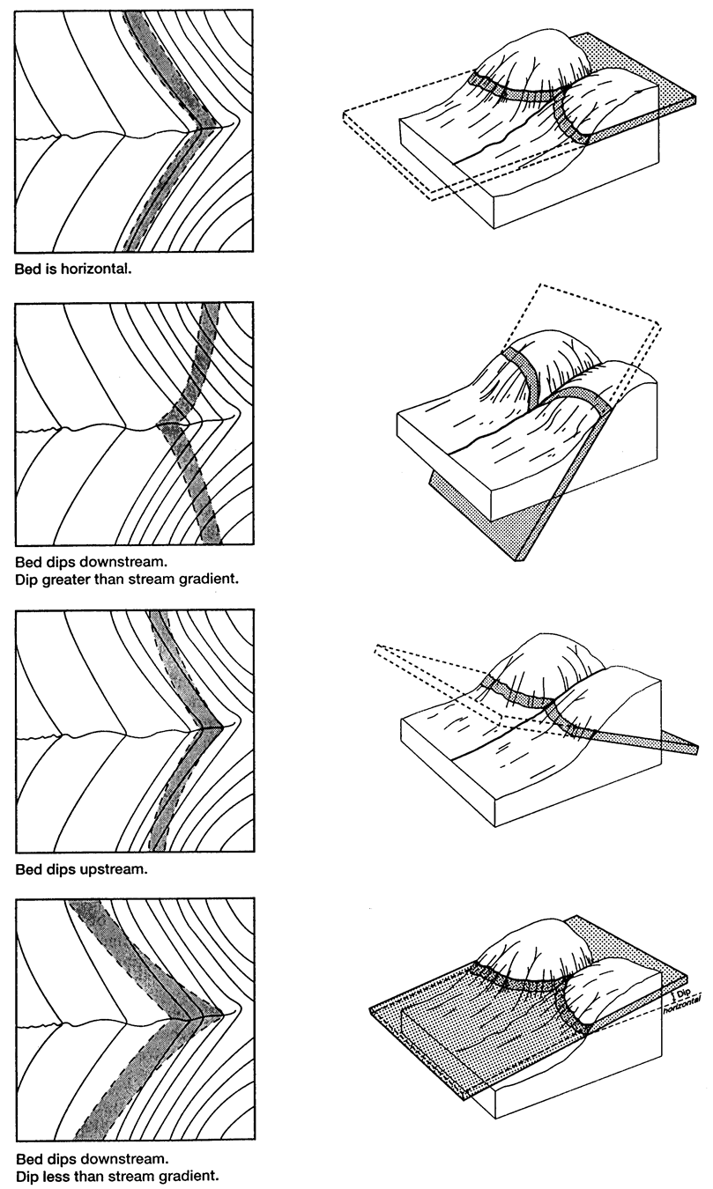
The “Rule of V’s” shows the relationship between outcrop patterns and formation dip
Geological Cross Sections

Basic Principles of Cross Section Construction
For rocks that have undergone low temperature (≤ 250˚ C) and low to moderate stress (≤ 200 MPa) deformation, a number of simplifying assumptions and principles are commonly used when constructing geologic cross sections. Interpretations that adhere to these guidelines and honor all available data are deemed “viable and admissible,” and cannot be discounted as possible interpretations of the subsurface geology. A cross section that does not honor the viability and admissibility criteria outlined below is automatically rejected as a possible interpretation of the subsurface geology because these cross sections require or imply that highly improbable or impossible physical situations existed before, during or after deformation. It is equally important to recognize, however, that viable and admissible cross sections are not automatically “correct,” and that many different viable and admissible cross sections can be drawn along any given section line.

Viability Criteria
Conservation of Layer Length and Area: During all stages of deformation, the lengths and areas of rock layers can be assumed to remain constant. Under plane strain conditions, these restraints are equivalent to “volume balance,” meaning that, excluding the effects of erosion, rocks that exist prior to the deformation cannot increase or decrease in volume during the deformation. In terms of faulting, this means that although layers may be shortened or extended by slip along a fault, the sum of the lengths of a faulted layer in all fault blocks is equivalent to the original length of that layer. When the slip is removed from all the faults, all the layers must also have realistic pre-faulting geometries. In terms of intrusions, this means that if the intrusions do not assimilate significant volumes of host rock, the lengths and areas of intruded country rocks will not change during the intrusion process. Consequently, it should be possible to “deflate” an intrusion and have all the surrounding rocks return to a realistic pre-intrusion geometry; there must be no holes or overlapping layers. This principle does not apply if there is significant penetrative deformation in the layers (e.g. cleavage).

Return to Regional: In the absence of significant basement topography, undeformed units throughout a region should each lie at a unique depth known as the “regional” for that unit. Away from intrusions and areas uplifted by faulting, each unit should “return to” its regional depth.

Fault Template Criterion: Every fault hanging-wall flat and ramp must have a corresponding footwall flat and ramp. Fault blocks restored to a pre-faulting geometry should match perfectly with no gaps or overlaps along the fault.

Admissibility Criteria
Honor Regional Tectonic Styles: The general structural style of a region is defined by the types and geometries of structures in that region: high angle reverse faults, intrusions, low angle thrust faults, detached extensional faults, salt domes or some combination of structures. Previous work and a general understanding of the tectonic setting of a region have typically established the kinds of structures that are present in an area. When drawing a cross section through an area you should always interpret and draw structures in a style that is compatible with the styles established by previous work or styles we expect in similar tectonic settings. This does not mean that you cannot discover a new or unique structure in an area; one that is different from the usual structural style. However, if you’re going to interpret a low angle thrust fault in the Black Hills, an area where Paleozoic rocks are dominated by intrusions and high-angle reverse faulting, you better have very good evidence to support your interpretation.

Occam’s Razor —Simpler is Better: Always strive to draw the simplest possible subsurface interpretation. Simple interpretations can be supported by very basic assumptions like the viability criteria. The applicability of these assumptions has been demonstrated in a number of studies in a variety of tectonic settings. In the absence of data constraining complexities in the subsurface, it is best to rely on the strength of the viability assumptions. Subsurface complexities may be present, but should not be stylistically added to a cross section; you must have evidence that such complexities exist!

Apparent Dips: Correct Use of Strike and Dip Data in Cross Sections
Cross sections must accurately and precisely reflect the orientation of formations crossed by the section line. Because section lines are rarely perpendicular to every strike and dip near the line of section, formations will exhibit apparent dips in the plane of the cross section. Correct representation of subsurface geometry requires the calculation and use of apparent dips. Plotting these dips on the cross section will insure that you honor your data during section construction and will illustrate to others, the surface constraints on your subsurface interpretation. Apparent dips are calculated and plotted as described below.

1. Project data along strike to the section line
• do not project across formation boundaries
• allowable projection distance is inversely proportional to the structural complexity between the data point and the section line
2. Calculate the apparent dip in the section plane using a nomogram (see Appendix 1) or trigonometric formula
3. Precisely plot the apparent dip in the section using a “tadpole” drawn on the topographic profile. The tail of the tadpole points in the dip direction and is inclined to the horizontal at an angle equal to the apparent dip angle.
4. Write the apparent dip angle above the tadpole on the section

Common Cross Section Errors
• topography-induced folding
• intrusion pipes and feeders don’t match between sections
• contacts on cross sections must match those on the map
• cross sections must be identical along their line of intersection
• kinematic linkage between intrusions and faults
• honor your surface dip data
• no blank spaces underground
• unsupported changes in formation thickness

Steps in making a topographic profile for a geologic cross section

Step 1: draw the cross section line over the topographic base map.
Step 2: Lay a thin strip of paper along the section line and mark the locations where topographic contour lines intersect the cross section line. Also mark the locations where slope changes (e.g. streams and ridge tops).
Step 3: Graph the elevations of the marked lines on your strip of paper. Make sure the vertical scale is equivalent to the horizontal (i.e. map) scale if you want a true-scale cross section.
Step 4: Connect your graphed dots to make a smooth topographic profile.

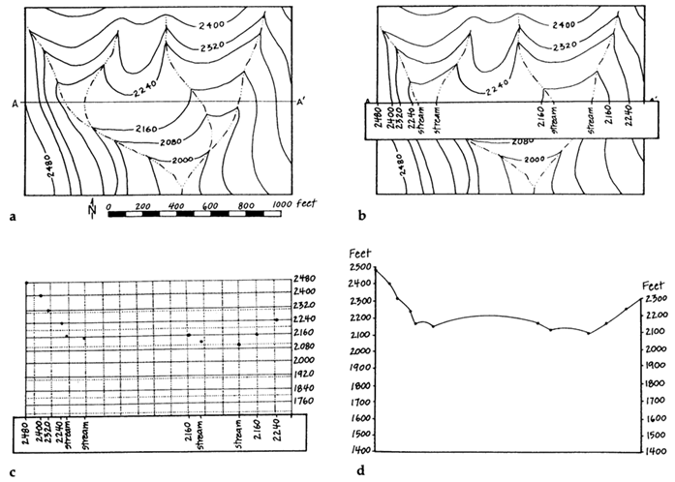

Constructing Geologic Cross Sections using Down-plunge Projection
Down-plunge projections can be used to construct geologic cross sections in areas where the topographic relief is relatively small and the structural geometries are relatively simple. In areas with complex structure or high relief, down-plunge methods can still be used to construct geologic cross sections, but there will be increasingly greater error in the projection.

Step 1: Before You Start
Determine the average orientation of the major fold axes in the map area. To do this, plot together on a stereonet, the axes of all the minor folds and intersection lineations you measured in the map area. Once these data are plotted together, visually estimate the vector mean of the lineations and plot this estimated mean as a new point on the stereoplot. Record this mean plunge and bearing at the bottom of your stereoplot and reserve it for later use. If you have access to a computer-based stereonet program, you may want to use the program to precisely and accurately calculate the mean. Remember you cannot determine the vector mean plunge and bearing by simply adding together all the bearings and finding their average, and then adding together all the plunges and finding their average.

Step 2: Preparing to Draw Your Map Projection Grid
Draw across your map, a light pencil line whose orientation is the same as the bearing of the average fold axis you determined in Step 1 above. Place your map on a tabletop or light table so that the down-plunge ends of the major folds are close to you and the up-plunge ends of the major folds are away from you. (i.e. the folds should be plunging toward you as you sit in front of your map.) Rotate the map slightly so that the light pencil line representing the average bearing of the fold axes is oriented vertically. Tape your map down in this orientation. Tape a sheet of velum or tracing paper over your map so that the long axis of the paper is parallel to the average fold axis bearing you determined in Step 1 above. The tracing paper must be large enough to completely cover the map area.

Step 3: Drawing Your Map Projection Grid
Once your map and overlay are taped down, complete the following steps in sequence. All of the drawing for this step will be done on the tracing paper overlay and should be done with a ruler or straightedge.
(a) draw three Reference Lines that are parallel to the average fold axis bearing and that extend across the entire map area. Draw one of the lines near the center of your map, and two lines that pass through the endpoints of your section line.
(b) starting at one edge of your map, draw a series of parallel, equally spaced lines that are perpendicular to the average fold axis bearing. Draw these lines so that their spacing (s) is small enough to allow many lines to cut across your map area. The spacing will be a function of the complexity of your map; accurate projection of more complex maps requires smaller line spacings whereas simple maps can be projected with wider line spacings.
(c) consecutively number each of the parallel lines you just drew, beginning with the line closest to you (i.e. on the down-plunge end of the major folds)

Step 4: Calculate the Spacing of the Cross Section Grid
To calculate the new spacing (s') that your map grid lines will have when you project them into your cross section plane, we use the equation:

where s is the spacing of your map grid lines and (plunge) is the average plunge angle of the major folds you determined in Step 1. The cross section grid spacing (s') will be larger than the map grid spacing (s) if your plunge angle is greater than 45˚, and smaller than the map grid spacing if the plunge angle is less than 45˚. If your cross section grid spacing is larger, folds in the cross section will appear "stretched out" compared to how they appear on the map. If your cross section grid spacing is smaller, folds in the cross section will appear "squished" compared to how they appear on the map. If the average plunge angle of your major folds is exactly 45˚, then your cross section grid is identical to your map grid and your cross section geometry will be identical to that of your map.

Step 5: Constructing Your Cross Section Grid
Calculate the total height of your cross section by multiplying s' by the number of grid lines you have on your Map Projection Grid. This is the minimum height your cross section will be, so make sure you design your final project so that it can accommodate a cross section of this height and still have room for labels, etc. Cut a new piece of velum or tracing paper that is at least as wide as your section line and as tall as the minimum height you just calculated. Tape this piece of paper over the two pieces of paper on which you have drawn your map and map Projection Grid. Tape it so that its long axis pointing away from you. This is the paper on which you will construct your cross section, but you must first construct a Cross Section Grid to project to.
Drawing with pencil on your cross section construction sheet, lightly trace over the Reference Lines you drew on your Map Projection Grid in Step 3. Extend these lines all the way to the top and bottom of the page. Beginning near the bottom of the page, draw in a line perpendicular to the Reference Lines. This is your first Cross Section Grid line, and it should extend all the way across the page. Moving up the page from the first grid line, draw in a series of Cross Section Grid lines that are perpendicular to the Reference Lines, and which are spaced a distance of s' from one another. Draw in the same number of lines that you have in your Map Projection Grid, and number each line consecutively in the same manner that you did in Step 3c. When you are finished, untape your Cross Section Grid sheet from the table.

Step 6: Projecting the Map into the Cross Section Plane
Place your Cross Section Grid sheet over the map and Map Projection Grid that are still taped to the tabletop. Line up the Reference Lines and the grid line labeled "1." Choose any particular contact on your map and mark on the Cross Section Grid sheet, the intersections between that contact and grid line one. When you have marked all the intersections with grid line one, slide your Cross Section Grid along the Reference Lines so that grid line 2 of the Cross Section Grid matches up with Grid Line 2 of your Map Projection Grid and mark the intersections between Grid Line 2 and the contact you have chosen. Repeat this process for all the grid lines until you have marked the intersection of one contact with every grid line of the Cross Section Grid. When you are done, connect the dots to create the smoothly curving cross sectional view of the contact you just projected.
To complete your projection, you must project each map contact in a similar fashion, consecutively aligning the Cross Section and Map Projection Grid lines, marking the contact intersections with each grid line, and then connecting all the intersection points to obtain a cross sectional view of the contact you projected. When you have projected all your map contacts onto the Cross Section Grid sheet, your Cross section Grid sheet is now your geologic cross section. However, it is not a complete cross section because we do not yet know how it "attaches" to the local topography, or more specifically, how to place the vertical scale along the edge of the section. You will use your topographic profile to do that in the next two steps.

Step 7: Construct a Topographic Profile along the Line of Section
Using a scrap piece of velum or graph paper, construct a topographic profile along your chosen line of section. Be sure to construct your section with no vertical exaggeration. Put a vertical scale on your section and mark the location of each geologic contact on the topographic profile.

Step 8: Placing the Topographic Profile and Vertical Scale on Your Cross Section
Tape your topographic profile to a tabletop. Flip your Cross Section over (i.e. rotate it about its short axis so that Grid Line 1 is now upside down and at the top of the page and you are looking through the back side of the velum; see notes below). On the "back side" of your section, locate the numbered Cross Section Grid line that is closest to your cross section line on your map (i.e. which numbered line was closest on the Map Projection Grid?). Place the flipped-over cross section sheet over the topographic profile so that the Cross Section Grid line closest to the map cross section line runs through the center of your topographic profile. Keeping the Reference Lines at the edge of the cross section aligned with the ends of your topographic profile, slowly slide the cross section up or down until the contacts marked on the topographic profile match those on the cross section. There is likely to be a slight (1-3 mm) misalignment of some of the contacts, but if you have done the projection right, and there is not too much relief or structural complexity in your area, you should be able to find a very good match by moving the cross section no more than 5-10 mm up or down.
When you have found the best match that minimizes all the contact misalignments, tape your flipped-over cross section sheet to the table over your topographic profile and trace the topographic profile and its associated scale onto the back of your cross section sheet. When you are finished tracing, remove the cross section sheet and hold it up to the light, view it on a light table, or over some white paper. You now have a projected cross section with topography and a vertical scale!

Why do we flip the cross section over and draw on its back?
Because we drafted our Cross Section Grid looking in the up-plunge direction of the structures, the "bottom" of our projected cross section contains the down-plunge ends of the structures and the "top" of the cross section contains the up-plunge ends of the structures. If you think about the map and how the 3-D structures intersect the map surface and the cross section surface, you will notice two important things:
1. map points on the up-plunge side of your cross section line should project into the subsurface of your cross section, below the topographic profile, and
2. map points on the down-plunge side of your cross section line should project into the air, above the topographic profile of your cross section.
If we were to draw on the "front" of our projected cross section, the down-plunge ends of our folds would appear at the top of our cross section, above ground! This is impossible. The reason we flip our cross section before adding the topography is to ensure that in our cross section, the down-plunge ends of your structures appear above ground, and that the up-plunge ends of the structures appear below ground.
Phanerozoic Stratigraphy of North America

1 Precambrian Basement: Foundation of the Continent
1.1 Archean Rocks
• Greenstone Belts
• Gray Granites
• High Grade Gneisses
• In the Archean, few basalts and andesites are around.
1.2 Early and Middle Proterozoic Rocks
• Although graywackes were still forming, light-colored, well-sorted quartz sandstones became more important.
• More mature sandstones were formed many were subsequently metamorphosed to quartzite. For example: Baraboo Sequence
• Stromatolites (wavy, laminated) structures formed by the accumulation of cyanobacteria.
1.3 Late Proterozoic Rocks
• Keweenawan Rift
• Grenville Orogeny
• Rodinian continental margins

2 The Paleozoic
2.1 The Setting
• The beginning of the Phanerozoic represents the largest punctuation mark of all time because of the appearance of complex life forms.
• This section treats the interval from ~700-500 million years ago (Vendian, Cambrian, and Early Ordovician).
• Profound unconformities mark both the top and the base of the sequence. The Sauk sequence was deposited during the Sauk transgression, a world-wide sea level rise which culminated in the flooding of nearly the entire North American craton in the early Ordovician 500 million years ago.
2.2 The Cambrian Craton
• There is a profound thickening of Cambrian rocks along the continental margins.
• Cratons are not perfectly flat, there are domes and arches. These can be caused by compression, extension, or thermal subsidence.
• Very few faults of any significance, most probably represent the surficial expression of basement fault zones.
• Transcontinental Arch, a broad upwarp. Along the arch, no Cambrian sediments are represented, the sea did not raise fast enough.
2.3 The Sauk Transgression
• General Setting
1.By the end of the Cambrian, Nearly three-fourths of the continent was flooded during the Sauk transgression. This sea was much like modern continental shelves except it was much larger.
2. Transgression rate: About ten miles per million years on average, the actual rate was more spasmodic. The maximum flood before the Sauk seas retreated was during the early Ordovician.
3. Paleomagnetic data indicate that North America Lay along the Equator and was oriented 90° clockwise to its present position.
• Quartz rich sand was dominant in most areas, some of which was glauconite bearing, shale was minor. When you think Cambrian, think extensive quartz sandstones.
1. The sand was derived from the craton. The craton was weathered and eroded for more than 1/2 billion years, so a huge volume of clastic material must have been available.
2. It was probably eroded and redeposited a number of times before it was eventually deposited in the eperic seas.
3. Cambrian Cratonic sandstones rank among the maturest in the world. They are noted for how perfectly the grains are rounded and sorted, and are almost pure quartz.
• By the close of the Cambrian, the vast supply of weathered quartz was used up, and much of the sedimentary source land was gradually being submerged. A great carbonate factory was turned on and worked its way toward the center of the continent.
1. Many of the limestones consist of shell debris, and display ripple marks, cross beds and other features indicating physical transport.
2. The critters present required agitated, well-oxygenated water with plenty of sunlight.
3. Oolites
4. Most of the limestones have subsequently been converted to dolomite through diagenesis.
• Since there is abundant evidence of wave and current action and a lack of deep water facies, it is interpreted that the Sauk sea was very shallow, probably no deeper than 100 m anywhere on the craton.
1. The presence of stromatolites suggests the approximate presence of sea level
2. Dessication (caused by drying out) cracks
3. Flat Pebble conglomerates
4. Glauconite forms in shallow seas where deposition rates are extremely slow.
2.4 The Later Ordovician
• Widespread unconformity was produced across the mid continent during the early Ordovician. At the height of the Sauk transgression, dolomite deposition was dominant. In the midcontinent, the unconformity is overlain by the St. Peter Sandstone.
1. The sea retreated to the continental margins.
2. Because the continental interior is very flat, and only a slight drop in sea level would have been needed to expose a considerable area.
3. The underlying Cambrian sands were the likely source. Only a little erosional truncation of the overlying dolomites would have been needed to reach these sands.
4. Classic transgressive deposit. Virtually all of the sand is nearshore facies.
• After deposition of the SPS, marine carbonate sediments formed across the entire craton
1. Many are >80-90% skeletal material, and are among the most fossiliferous in the world.
2. Like the during the Cambrian, the craton was nearly completely flooded again.
3. Probably somewhat deeper.
• In the Appalachian region, the later Ordovician sequence is quite different than what has just been described.
1. More deeper water facies, with black shales, graywackes, and cherts.
2. Pelagic (deep water) sediment is an oddity for continental interiors, and must record a change in source areas.
3. Northern Appalachians are almost all dark shales, and thicker.
4. Farther east, volcanic rocks occur within the Ordovician Succession, indicating that volcanic islands were forming here.
• Taconic Orogeny
2.5 The Silurian and Devonian
• Aftermath of the Taconic Orogeny
• Silurian and Devonian strata are scattered widely over the craton. This could be the result of nondeposition or erosion during a significant Hiatus in the early Devonian about 400 million years ago. This is the boundary between the Tippecanoe and Kaskaskia sequences. Middle Silurian facies are dominated by marine carbonates and lesser shale. The fossils present indicate a shallow sea with uniform conditions over an immense region. Similar conditions persisted in the Devonian as well.
• Lots of Carbonate Reef environments
• Evaporites
2.5.1 Middle-Upper Devonian Strata of North America (Early Kaskaskia)
• Kaskaskia strata rest unconformably above older strata
1. Similar to the base of the St. Peter Sandstone
2. Emerged lowland for a few million years
• Basins and arches became more sharply delineated
1. Upper Devonian Strata is more widespread
2. Michigan basin continued to subside, the Williston and Forrest City basins were also actively subsiding.
3. Acadian Orogeny
4. Arctic-Cordilleran Orogenies
• Franklin Orogenic Belt
• Ellesmerian
• Antler Orogeny
2.6 Mississippian Rocks (362-322 my ago)
• Last widespread carbonate producing epeiric sea in north America
• Limestones rich in crinoid fragments predominated and display conspicuous clastic textures including ripple marks, cross bedding and oolites.
• Organic reefs were present but not as widespread.
• The end of the Mississippian is marked by a major p between the Kaskaskia and Absaroka Sequences.
2.7 Pennsylvanian Rocks
A. Beginning in the late Mississippian and persisting through the early Permian time, strata deposited within North American craton display a striking repetitive pattern.
B. In the eastern States, upper Mississippian strata display ss-sh-ls sets repeated several times vertically. These probably represent deltaic deposits from rivers draining from Canada and the Appalachians.
C. Practically all Pennsylvanian strata display a repetitive pattern, the most striking of which occurs in the coal-bearing sequences.
2.8 Permian-Early Triassic Rocks
• The close of the Paleozoic is marked by the fall in sea level and represents a period of time when North America was characterized by extensive emergence.
• Permian Basin, Phosphoria sea.
• This period of time is marked by extensive redbeds and evaporites throughout the western U.S.
• Great desert that rivaled the Sahara in the Rocky Mountain-Grand Canyon area
2.9 Tectonics
• Marathon-Ouachita Orogeny (Oklahoma /Arkansas, Texas)
• Ancestral Rocky Mountain Orogeny (Western OK, Colorado, NM)
• Appalachian (Alleghenian) Orogeny . The final closing of the Iapetus ocean and the collision of Gondwanaland and North America.

3 The Mesozoic Era
3.1 The Opening of the North Atlantic
3.2 Triassic Period
A. Triassic strata is very similar to Permian discussed earlier
B. Red sandy Alluvial plane, mostly terrestrial sediments
C. Marine Conditions existed only in the west
D. Still a volcanic margin arc along the western margin
3.3 Jurassic Period
A. Navajo Desert
B. Sundance Formation
C. Morrison Formation.
3.4 Cretaceous Period
A. Major transgression and seas were as high then as ever before. Some epeiric seas experienced unprecedented depths exceeding several hundred meters. It was the last major flood of the continent.
B. Seas transgressed from the north and south
C. Most K rocks are in the west, others are part of the coastal plains
D. clastic wedges shed from the mountains to the west
3.5 Cordilleran Tectonics
A. Cordillera is the name for the western margin of North America.
B. Remained a passive margin for much of the early Paleozoic. Became an active margin an has remained such since the Devonian. Subduction became more rapid in the Mesozoic.
C. Sonomia and the Sierran Arc
D. Sevier Orogeny. Late Cretaceous
E. Laramide Orogeny. Late Cretaceous and Early Tertiary

4 The Cenozoic Era
1.Introduction and Chronology
2.Coastal plain strata
3.Tertiary strata of the Cordilleran Region.
4.Cordilleran Tectonic History
A. Laramide Orogeny Continued
B. Intermontane Basins -- Thick accumulations of materials shed from uplifted ranges
C. Resumption of Arc Volcanism
D. San Andreas Fault
E. Basin and Range
F. Columbia Plateau
G. Colorado Plateau
H. Cascade Volcanism
I. Yellowstone Hot Spot and Snake River Plain
Tectonic History of the U.S. Cordillera

1. Continental Scale Structure of North America
North America consists of an older interior craton rimmed by five Phanerozoic (570 – 0 Ma) orogenic belts
A. North American Craton
• the craton is an amalgamation of older (> 1.0 Ga) crustal fragments that were accreted during a variety of collisional events and failed rifting events
- these rocks form the “crystalline basement” of the interior of the continent
• subdivision of basement rocks of the craton is based on tectonic affinity and age
• basement rocks are commonly overlain by a veneer of lightly deformed, subhorizontal, Paleozoic sedimentary rocks
• portions of the craton and shield are tectonically active (i.e. seismically active) due to the reactivation of older faults and crustal discontinuities due to tectonic events along the continental margin or due to epeirogenic processes
B. North American Phanerozoic Orogens
• these orogenic belts formed largely by continent-continent or subduction-related collisions
- continent-continent collision results in accretion of mature (> 200 Ma old) lithosphere
- subduction collision results in accretion of immature (< 200 Ma old) oceanic material including volcanic arcs, accretionary wedges and volcanic plateaus
1. Cordillera
2. Franklin
3. Caledonide
4. Appalachian-Ouachita
5. Sierra Madre

2. Tectonic Subdivisions of the Craton
A. Grenville Province (1.3-1.0 Ga)
• collisional orogen extending nearly 5000 km from Mexico to Labrador
• formed during assembly of a supercontinent named Rodinia
• dissected during later continental rifting and pieces are now preserved in many continents, including South America and Africa
B. Keweenawan Rift Province (~1.1 Ga)
• failed rifting event causing large outpourings of basaltic lavas
• evident in subsurface from gravity and magnetic anomalies
C. Yavapai and Mazatzal Provinces (1.8-1.6 Ga)
D. Trans-Hudson and Penokean Provinces (1.9-1.8 Ga)
E. Superior, Slave and Wyoming Provinces (Archean, > 2.5 Ga)

3. The Cordilleran Orogenic Belt
• perhaps the longest-lived orogenic belt on the face of the Earth
- subduction convergence has continued here since the rifting and breakup of Rodinia between 730 –550 Ma
- in total, this orogenic belt is a continuous chain of mountains extending from Alaska to the tip of South America
• geology here is a result of every type of plate interaction except continent-continent collision
• this mountain belt is active today and along it we have a variety of tectonic styles
- oblique subduction convergence south from Alaska to the Mendocino triple junction
- strike-slip deformation south from Cape Mendocino to the Gulf of California
- active spreading in the Gulf of California
- subduction convergence and local strike-slip deformation from Central America to Argentina
• classic setting for the identification of “suspect terranes,” or fragments of crust or sedimentary rock that were created elsewhere and subsequently accreted to the continental margin
A. Paleozoic and Mesozoic Tectonics in the U.S. Cordillera
1. Antler Orogeny (Devonian - earliest Mississippian)
• accretion of an island arc formed above a westward-dipping subduction zone
• sediment deposited in foreland basins in eastern Nevada
2. Sonoma Orogeny (Permian-Triassic)
• accretion of an island arc formed above a westward-dipping subduction zone
• polarity of subduction flips during this event
- continental arc magmatism begins along western North America
3. Nevadan Orogeny (Late Jurassic)
• accretion of several island arcs or microcontinents
- arc-arc collision
• highly oblique convergence
- creates right-lateral strike-slip fault zones and sutures
• closes a small, doubly subducting oceanic basin
- creates an Andean-style margin along western North America
- to the west there is now a significant expanse of the Farallon oceanic plate
4. Sevier Orogeny (Latest Jurassic to Late Cretaceous)
• fold and thrust belt formation along the majority of the continental margin, from Canada into Mexico
- major remnants of this thrust belt are found in southwestern Wyoming
• roots of Sierra Nevada batholith intruded during continental arc magmatism
- extensive thickening of crust
• Great Valley sequence deposited in fore-arc basin
• Franciscan Complex rocks deposited and deformed in accretionary prism
• extensive deposition in foreland basins on the eastern side of tectonic highlands
5. Laramide Orogeny (Latest Cretaceous to Eocene)
• basement-involved reverse faults cause “thick-skinned” deformation in the Colorado Plateau, Rocky Mountain foreland and Black Hills of South Dakota
- creates, among others, the Bighorn Mountains, Wind River Mountains, Uinta Mountains, Uncompahgre Uplift and Rocky Mountain Front Range
- some uplifted as much as 30,000 feet
• monoclinal folding of sedimentary cover over uplifted basement rocks
• intermontane basins develop between basement uplifts
- coeval stratigraphy in the basins thickens and coarsens toward the uplifts
• uplifts are enigmatic because they are so far from the inferred continental margin and because they have widely varying orientations
- hypothesized to be inverted normal faults of Proterozoic age
- thought to be associated with accelerated convergence rates, low-angle subduction, and the subduction of young, hot, buoyant oceanic crust

B. Cenozoic Tectonics in the U.S. Cordillera
• at the end of the Laramide, when motions between the North American, Kula and Farallon plates changed dramatically, convergence rates decreased rapidly
• oblique subduction of a spreading ridge beginning around 30 Ma
- creates a triple junction and an ever-lengthening San Andreas transform boundary
• 10-15 million years after ridge subduction, extensional deformation begins in the Rio Grande Rift and the Basin and Range Province of Nevada
- general structural style is one of alternating horsts and grabens, or half-grabens
- extensional deformation has migrated outward and northward over the last 10 million years
- crosscuts Sevier age fold-and-thrust belt structures in Utah and Wyoming
- creates the Teton uplift in northwestern Wyoming, beginning around 9 Ma
• eruption of Columbia River Flood Basalts between 17-6 Ma, most between 17-15.5 Ma
• initiation of Yellowstone hot spot.
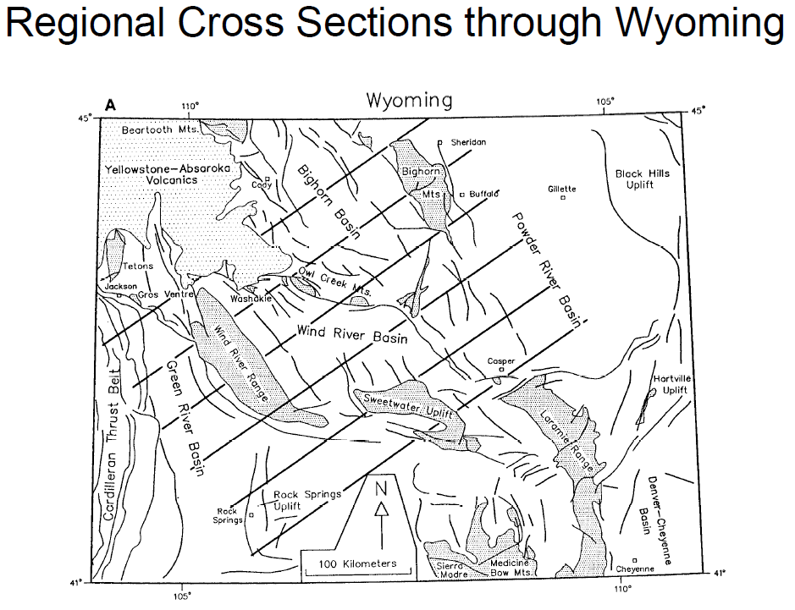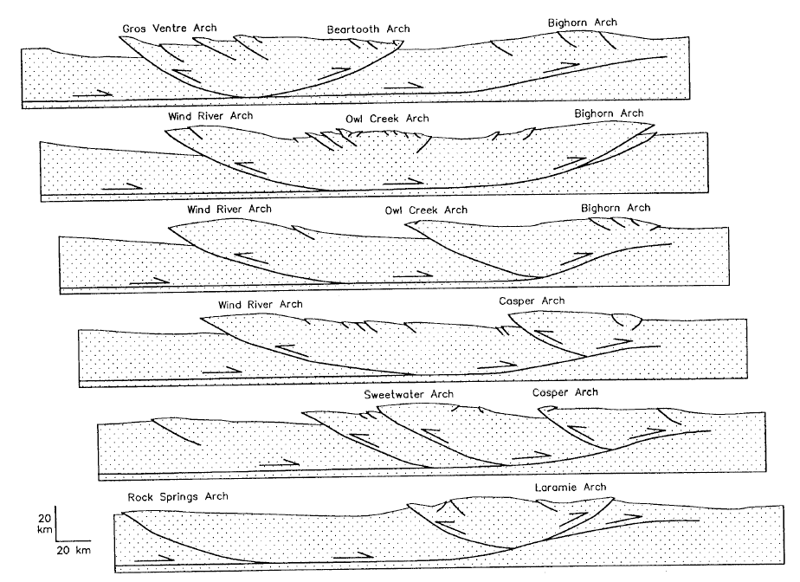
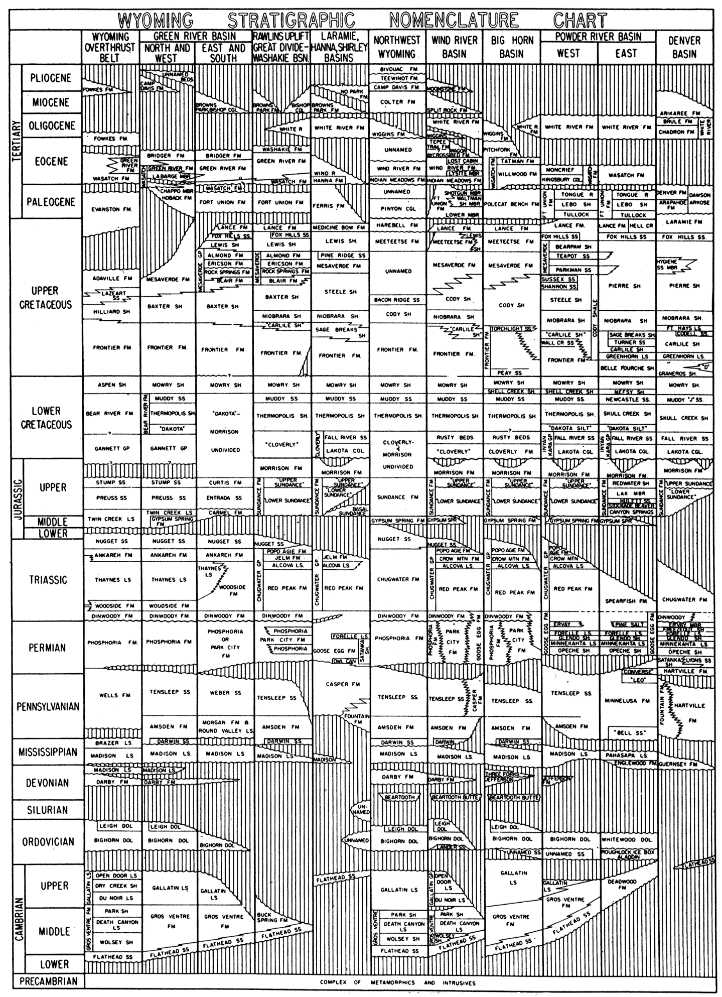
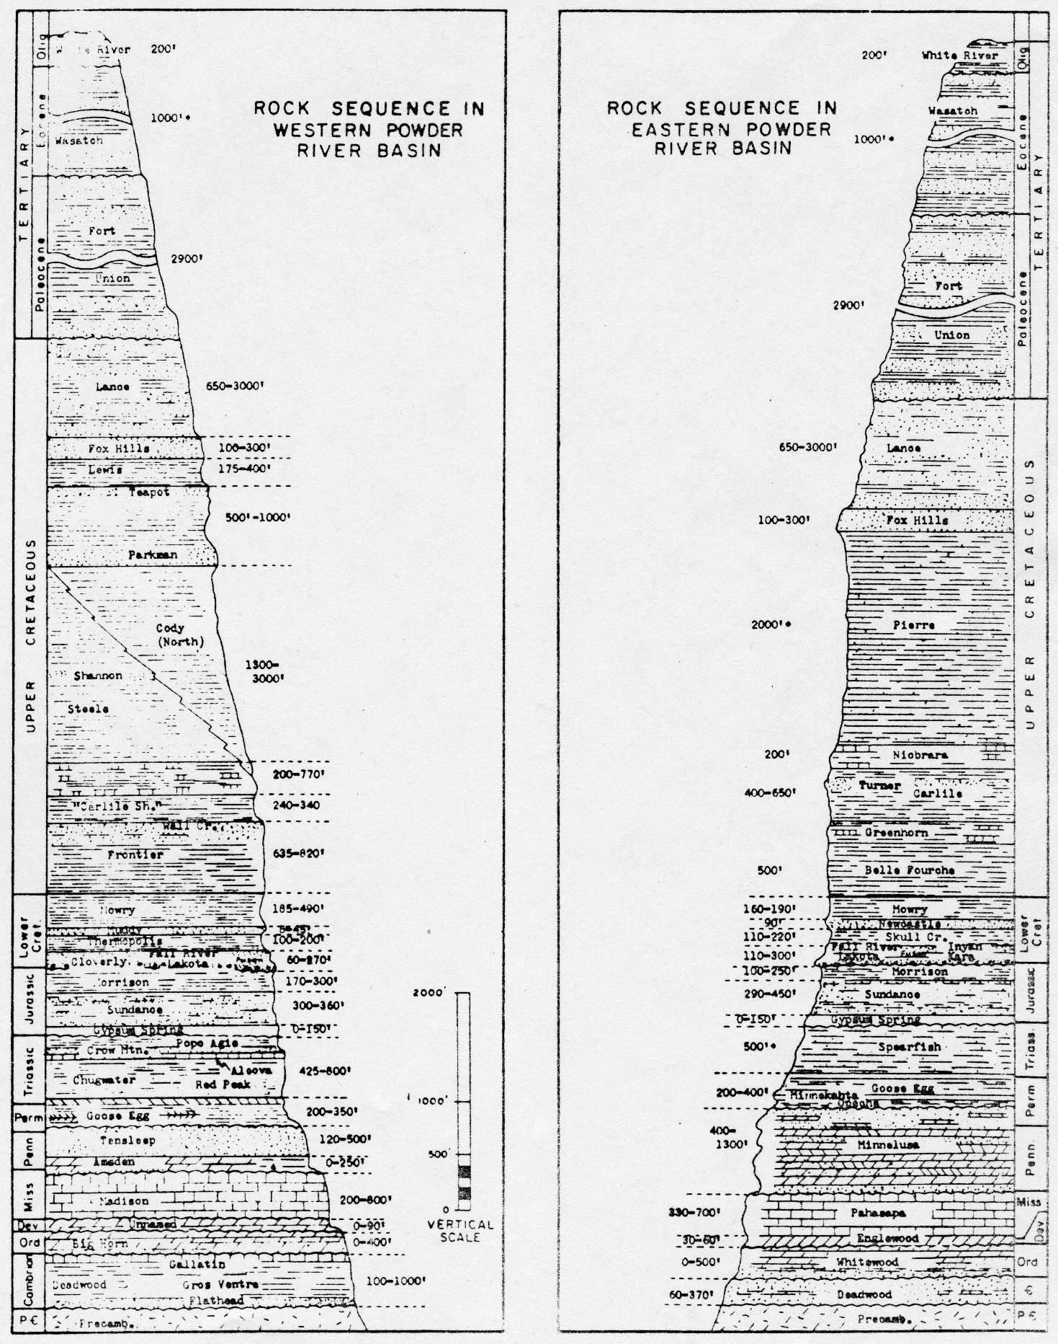

Black Hills Precambrian Geology

1. Archean Rocks
A. Present in the Black Hills but are limited to two small areas
1. Along Little Elk Creek (NE)
2. Near Bear Mountain (SW)
B. Part of the Wyoming Archean province
C. Both have granites (tonalites) that are about 2.5 billion years old
• These granites intrude older high grade metasedimentary successions.
D. Likely the foundation for the rest of the Precambrian rocks in the Black Hills. These rock are unconformably overlain by younger metasedimentary rocks.

2. Proterozoic Rocks
A. 99% of all exposed Precambrian rocks in the Black Hills area
B. Consists of metasedimentary, metavolcanic and intrusive granitic rocks
C. At least two depositional successions
1. ~2.2 bya
2. ~1.9-2.0 bya
D. As many as five deformational and metamorphic events have been documented
• typically tightly folded and have well-developed, steeply inclined foliation
• dominant structural grain is NNW
G. Intruded by the ~1.7 bya post tectonic, S-type Harney Peak Batholith
H. Part of the Trans-Hudson belt

3. Summary of Major Mapped Early Proterozoic Rocks
A. Xqi
• Occur in the Nemo area
• Metaconglomerate, Quartzites, BIF. Some conglomerates are uraniferous
• Deposited in a rift environment
• Unconformably overlie the Little Elk Granite
• Intruded by the 2.17 bya gabbroic, gravity differentiated Nemo Sill (Xmg)
B. Xgf
• Exposed in the Nemo area
• Conglomerate, quartzite, marble (shallow water facies)
• Lateral equivalent to southern units?
C. Xpb
• Greenstones (pillowed), BIFs, slates
• 1.97 bya
• Homestake Formation and associated rocks in the Lead and Rochford areas
• Occurrence of Black Hills gold.
D. Xgw-Xif-Xcg-Xbs-Xms
• Schists, BIFS, metagraywackes, metaconglomerate, quartzite, phyllite, metatuff, minor greenstones. Mainly deep marine sedimentary and volcanic rocks.
• Graywackes are the most abundant
• Conformably overlie Xpb
• Present in the southern and eastern Black Hills

E. Xp
• Youngest metasedimentary succession
• Mainly poorly exposed black slate and phyllite
• Repeated several times by folding
• Present in the Deerfield Lake and Pactola Lake areas in the western Black Hills
F. Harney Peak Granite
• Present in the southern Black Hills including Mount Rushmore
• Topographic high of the uplift, very resistant rock
• Associated pegmatites
• Contact metamorphic zones
• Mechanism of intrusion has a significant effect on the country rock

Regional Stratigraphy project

Purpose and Introduction
The purpose of this project is to introduce you to the stratigraphy of the western Powder River Basin and instruct you in the methods of measuring and presenting stratigraphic columns. You will spend three days measuring and describing the stratigraphic units along the eastern flank of the Big Horn Mountains. You will first measure and describe the Archean and Cambrian rocks along US 14 west of Dayton, WY near Steamboat Mountain. Next you will measure and describe Ordovician through Pennsylvanian strata exposed along Crazy Woman Canyon. Lastly, you will measure and describe Permian through Cretaceous units in the Bud Love Big Game Winter Refuge northwest of Buffalo. Base maps of these areas will be provided daily.
Each day you will record this stratigraphic information in your field notebook. Once completed, you will be required to submit three individual stratigraphic columns, one for each day's work, for grading. It would be wise to work on each day’s column that evening. Here are the guidelines for the formal drafts of the columns:

Helpful Hints
• use 1” : 50’ as the vertical scale in your notebook.
• try to capture the variability of units on the scale of 20-40’
• use the evening of each day to work on that day's column
• calculate the maximum thickness of your three sections before you cut your paper; you don't want to end up with a piece that is too small to fit your largest section!
• use the standard lithologic symbols found at the back of the guidebook when filling in your sections
• the right side of each of your sections should be a weathering profile that reflects each units’ relative resistance to erosion.
• use the reference section for the Big Horn Basin as a template for the construction of your sections.

Project Components, Guidelines and Layout
1. Your final stratigraphic columns should be drafted at a scale of 1' to 100".
- They should be drafted as neatly as possible on the provided graph paper.
3. They should be in appropriate detail that reflects the variability of each formation.
4. The following information should be included in each of the columns:
• a descriptive title of each section including the location where it was measured,
• the lithostratigraphic and chronostratigraphic nomenclature,
• the thickness that you measured,
• appropriate patterns and symbols,
• a weathering profile,
• brief lithologic descriptions.

At the end of this project you will turn in:
1. Three graphical stratigraphic columns, all on one sheet of paper
2. Brief written descriptions of each formation, including thicknesses, all written adjacent to the part of the stratigraphic column to which they pertain (i.e. on the same large sheet of paper as your graphical stratigraphic columns)
3. Your field notebook

Project Grading
• Stratigraphic Columns 100 pts
• Field notebook 20 pts
120 pts total
Amsden Creek Mapping Project

Purpose and Introduction
This project is a two-day introduction to geologic mapping. During this project you will begin to learn how to locate yourself on a topographic map, recognize, define and map rock units, collect structural data, locate formation contacts, take quality field notes and make field cross sections.
The field area is located within state-owned land of the Amsden Creek Big Game Winter Range, northwest of Dayton, Wyoming. Because this project is an introduction to geologic mapping, we will begin mapping as a single large group. The faculty will remain with the group for a least one half of the first day, and you will be free to map the area with your partner thereafter. The geology of the area consists of homoclinally dipping Mesozoic and Paleozoic strata: the same rocks that the class described and measured in the Regional Stratigraphy Project. No mappable faults or stratigraphic pinch-outs are present in this area.

Helpful Hints
• review your field notes from the Regional Stratigraphy Project to aid in defining rock units.
• structure, unit thicknesses, and geomorphic expression must agree with one another.
• draw cross sections in your field notes to determine structural and stratigraphic relationships.
• be sure to have complete coverage of structural data throughout the map area; you should have at least fifteen strike and dip measurements on your finished map.

Project Components and Layout
Follow the Guidelines for Map and Cross Section construction when preparing your project. The map, explanation and cross section should be constructed on the paper you are provided. You are free to design the layout of these items any way you like, but they all must fit on the same sheet of paper.

When mapping in the field or drawing your cross section, observe the following guidelines:
• rock units below the Cretaceous should be mapped separately.
• in the Cretaceous succession, map the Cloverly Fm. as a separate unit, and lump all younger Cretaceous units together as Ku (Cretaceous Strata, undivided).
• draw your geologic cross section down to an elevation of 1000' above sea level.
At the end of this project you will turn in a final colored and inked map, the map explanation with brief descriptions and formal names for each map unit, one geologic cross section assigned by the instructor, your field notebook your field map

Project Grading
• Final Map 40 pts
• Explanation 10 pts
• Cross Section 30 pts
• Field Maps 10 pts
• Field Notebook 20 pts
110 pts total

South Fork Mapping Project

Overview
The South Fork slide (SFS) is exposed over an area of 800 km2 in northwest Wyoming, and its evolution is connected in space and time to the adjacent and overlying 49.19 Ma Heart Mountain slide (HMS). The youngest rocks deformed as part of the SFS are the Eocene Willwood Formation sands and mudstones, which have a U/Pb detrital zircon youngest depositional age (TuffZirc calculation) of 51.80 Ma as well as a spectrum of older zircons that were eroded from the Sevier Highlands to the west and the Archean Beartooth uplift to the north (n=379 U-Pb zircon ages). The SFS is overlain by allochthonous Paleozoic carbonate and Eocene volcanic rocks of the HMS. The SFS deformation involves shallowly plunging thin-skinned folds that trend northeast-southwest, where the slip surface could have been the top of the Jurassic Gypsum Springs Formation. Detailed mapping reveals the absence of any cleavage or joints and a plethora of minor structures unreported in any thin-skinned belt as well as the fact that nearly a third of the exposed allochthonous sediments are overturned. Calcite in Sundance Formation limestones is mechanically twinned, and the resultant strain analysis reveals that the pre-detachment Sevier layer-parallel shortening strain axes (31/31 samples; n p 1231 twins) are now in a random orientation. Synemplacement calcite veins record a horizontal shortening strain parallel to the veins. Neither calcite strain data set has any record of a strain overprint (low negative expected values). Rare slip indicators in the basal Sundance suggest northwest-southeast motion. Poorly constrained cross sections and palinspastic restorations indicate 125 km of shortening (and uncertain transport distances), and the above evidence suggests that the SFS formed as an Eocene landslide slightly earlier than the HMS. The SFS, then, represents the largest single allochthon (terrestrial or marine) that maintained its internal stratigraphy and did not disaggregate while in motion.

Purpose and Introduction
\Like with the Mickelson project that we will do in a few days, this area is in the vicinity of the Heart Mountain slide. While not as famous or well studied as its younger cousin, the geology of this area is rich in complexity and will be a nice challenge for you. This project is entirely on private land, and the only road access is from the Carter Mountain road. It will be best to start high each day, and then walk down hill in a series of strike parallel traverses. The stratigraphy will include Mesozoic rocks and include the section from the Sundance through the Frontier. The most notable difference here as compared to where you have seen these rocks before is that the Morrison Formation is much thicker, and contains chert pebble conglomerate in the middle of the section. Eocene rocks of the Willwood Formation also are present here. The structure here is rich in complexity. You will find both folds and faults. The exposure is excellent as well. So be careful that you spend the time needed to solve the structure.

Project Components and Layout
Follow the Guidelines for Map and Cross Section construction when preparing your project. The map, explanation and cross section should be constructed on the paper you are provided. You are free to design the layout of these items any way you like, but they all must fit on the same sheet of paper.

When mapping in the field or drawing cross sections, observe the following guidelines: Draw you cross section deep enough to show all of the structure. This will be the most challenging cross section that you will draw at camp.

At the end of this project you will turn in
1. a final colored and inked map,
2. the map explanation with brief descriptions and formal names for each map unit,
3. a geologic cross section assigned by the instructor(s),
4. your field notebook

Project Grading
• Field Map 10 pts
• Final Map 60 pts
• Explanation 20 pts
• Cross Sections 30 pts
• Field Notebook 20 pts
140 pts total

Mickelson (Heart Mountain) Mapping Project

Purpose and Introduction
This mapping area is in part of the Heart Mountain Slide area. The Heart Mountain Slide is a classic structure whose important features are outlined in the accompanying field guide (Malone and others, 1999). This area consists of gently dipping upper Paleozoic and Mesozoic strata that are cut by steeply-inclined dip-slip faults, allochthonous Paleozoic rocks that are bounded below by the gently inclined Heart Mountain Slide base, and Eocene volcanic and plutonic rocks of the Absaroka Volcanic Supergroup. You will have three field days and one drafting day to complete this project.

Be Careful. Grizzly bears and moose use this area.

In this area, you will be mapping in an area with limited outcrop, and little alluvium. . Float mapping is important. You may find yourself using more dashed contacts on this map.

Project Components and Layout
Follow the Guidelines for Map and Cross Section construction when preparing your project. The map, explanation and cross sections should be constructed on the paper you are provided. You are free to design the layout of these items any way you like, but they all must fit on the same sheet of paper.

When mapping in the field or drawing cross sections, observe the following guidelines:
• Draw cross sections down to a depth of 5000’ above sea level

At the end of this project you will turn in
1. a final colored and inked map,
2. the map explanation with brief descriptions and formal names for each map unit,
3. two geologic cross sections assigned by the instructor(s),
4. your field notebook

Project Grading
• Field Map 10 pts
• Final Map 60 pts
• Explanation 20 pts
• Cross Sections (2 @ 25 pts ea) 60 pts
• Field Notebook 20 pts
170 pts total

Stratigraphic Units in The Mickelson (Heart Mountain) Area

Tertiary
Wapiti Formation (Tw) – Interbedded andesitic/mafic breccia, lava flows, and volcanic siltstone, sandstone, and conglomerate; weathers brown and gray, thickness >400 ft in the map area.
All volcanic rocks are allochthonous.
Crandall Conglomerate (Eocene) – Limestone cobble and boulder conglomerate. Locally > 50 ft. thick. Small patches in pre-volcanic paleotopography.

Triassic
Chugwater Formation (TRc) – Red shale, siltstone, and sandstone, gypsiferous in places. Thickness, 650-750 ft.

Triassic-Permian
Park City and Dinwoody Formations (TR-Ppcd)
Dinwoody is Triassic in age and consists of yellow-brown, gray, and red siltstone, gypsum, and dolomite. Thickness 20-50 ft.
Park City is Permian in age and consists of siliceous limestone and dolomite, nodular chert, and brown shale. Thickness 70-110 ft.

Pennsylvanian
Tensleep Sandstone (lPt) – Light reddish gray well-sorted, cross-bedded, massive sandstone; thin beds of limestone and dolomite in the lower part. Thickness: 170-220 ft.
Amsden Formation (IPa) – Interbedded red shale, purple shale, dolomite, limestone and minor sandstone. Thickness 250-300 ft.

Mississippian
Madison Limestone (Mm) – Massive light gray limestone. Thickness 700-900 ft in the lower plate of the Heart Mountain Detachment; the thickness is variable in the upper plate. All Madison exposed here is allochthonous.

Devonian
Jefferson – Three Forks Formations (Djtf) -- (present only in subsurface here). Thickness 250 ft.

Ordovician
Big Horn Dolomite (Ob) -- (present only in subsurface here). Thickness 400 ft.

Cambrian
Gallatin Group – Gros Ventre Formation (Cgg) – (present only in subsurface here). Thickness 1200 ft.
Flathead Sandstone (Cf) -- (present only in subsurface here). Thickness 150 ft.
Precambrian
Granite and Gneiss, undivided (PCg) -- (present only in subsurface here).

Bald Mountain Mapping Project

Purpose and Introduction
The principal goal is to simulate a Rare Earth Element exploration project. The orebody here is the basal Flathead Sandstone. Here the Flathead is arkosic and conglomeratic near the contact with the underlying Archean granite. Rare Earth Elements are concentrated in the basal Flathead, where late Precambrian weathering of the underlying granite yielded detrital monazite, zircon, and apatite, each of which are concentrated in Rare Earth Elements. This type of deposit is known as a paleo placer. Basement rocks are mostly 2885 Ma alkali feldspar granite and pegmatite, which range from massive to strongly foliated. Mafic dikes of various ages and lithologies crosscut the granite. The pegmatite in the basement rocks is the likely source for the detrital monazite, zircon, and apatite.
Your job is to make a geologic map of the area. The principal contact is the base of the Flathead, which here is very gently inclined. You are to delineate arkosic and conglomeratic zones in the flathead. In the granite, you are to define the pegmatite bodies and mafic dikes withing the basement alkali feldspar granite and record the orientation of foliation.
There is no cross section associated with this project, but you will right a short evaluative report that discusses where in this area are the most likely to have the most valuable deposits. You also will prepare a stereonet of basement rock fabric data. More information will be provided at the beginning of the project.

Project Grading
• Final Map 50 pts
• Explanation/Report 50 pts
• Stereonet 10 pts
• Field Notebook 20 pts
130 pts total

Steerhead Mapping Project

Purpose and Introduction
The purpose of this project is to expose you to the mapping of faults, Paleozoic bedrock and syntectonic growth strata associated with a classic Laramide uplift. You are given two field days and one drafting day to complete a geologic map and two cross sections of a portion of the Steerhead Ranch, roughly ten miles west of Buffalo, Wyoming. The area consists of Archean igneous and metamorphic basement rocks nonconformably overlain by Paleozoic (Cambrian-Pennsylvanian) cratonic sedimentary rocks. Both Archean and Paleozoic rocks were deformed during the Laramide Orogeny and numerous faults of various orientations and slip sense occur within the area. The principal structure of the area is the Clear Creek Thrust, one of the major range-bounding faults that carries the Bighorn Mountains above it. A thick succession of syntectonic Tertiary gravel occurs within both the hanging wall and footwall of the fault.
When constructing your map and cross sections, be mindful of what we know about the regional structural geology. The map area is largely a hanging-wall anticline developed above a basement fault and any subsidiary faults and folds should have geometries similar to those documented in similar structures. Tear faults and extensional faults both exist in this mapping area.

Helpful Hints
• review the criteria for recognizing faults in the field (e.g. stratigraphic omission or duplication, abrupt changes in strike, juxtaposition of units not normally adjacent).
• review and understand the 3-D geometries of tear faults and extensional faults associated with Laramide uplifts - don't interpret structures that differ vastly from these well-documented types without very compelling evidence.
• draw schematic maps and cross sections in your field notes to help you figure out complex geometries or structural relationships.
• the resolution of your map constrains what you can put on it; in other words, if a feature is too small to appear on your map (e.g. a fault with 5' of offset), then you can't map it!

Project Components, Guidelines and Layout
Follow the Guidelines for Map and Cross Section construction when preparing your project. The map, explanation and both cross sections should be constructed on the paper you are provided. You are free to design the layout of these items any way you like, but they all must fit on the same sheet of paper.

When mapping in the field or drawing your cross sections, observe the following guidelines:
• map all gravel in the area as Tertiary Wasatch (Tw) Formation.
• map the Gallatin and Gros Ventre formations as one unit, the Gallatin – Gros Ventre (Cgg)
• fill in the footwall of your cross section with a "normal" stratigraphic sequence.
• draw cross sections down to a depth of 4000' above sea level.

At the end of this project you will turn in:
1. a final colored and inked map,
2. the map explanation with brief descriptions and formal names for each map unit,
3. two geologic cross sections assigned by the instructor(s),
4. your field notebook, and
5. Your field map

Project Grading
• Final Map 60 pts
• Explanation 20 pts
• Cross Sections (2 @ 30 pts ea) 60 pts
• Field Map 10 pts
• Field Notebook 20 pts
170 pts total
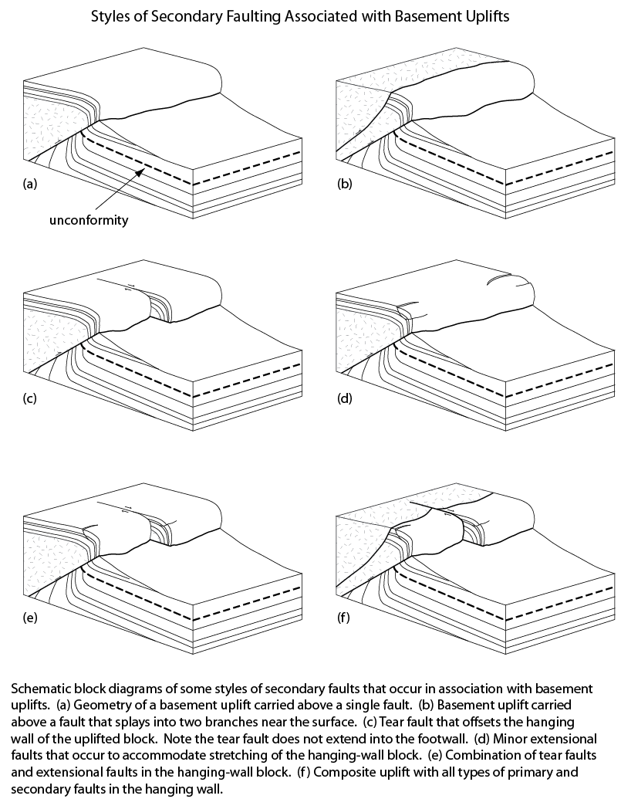

Appendix 1:
Essential Analysis Tools and Techniques for Field Geology

Field Description of Rocks

Field description of rocks is an essential component of geological fieldwork. Geologists must be able to use hand-specimens and outcrop-scale observations to derive a thorough and accurate description of any rock they encounter in the field. Following are some brief outlines to help you remember the steps involved in basic rock description. These are not meant to be comprehensive, but are intended to remind beginning geologists what to look for and what kinds of questions to ask themselves when they are examining rocks in the field.

Sedimentary Rocks
1 General Rock Type (conglomerate, sandstone, shale, mudstone, etc.)
2 Color (fresh and weathered)
3 Texture
3.1 clastic
3.1.1 % grains
• grain size: coarse (> 2 mm), medium (2 - 1/16 mm), fine (< 1/16 mm)
• sorting (well, moderate, poorly)
• surface texture (e.g., polished, frosted, etc.)
• roundness
3.1.2 carbonate allochems
• % intraclasts
• % ooids
• fossil and fossil fragments (identify when possible)
3.1.3 % detrital matrix
• sand or mud?
• micrite (i.e. microcrystalline calcite mud)
3.1.4 cement
• composition
• degree of cementation
3.2 crystalline
3.2.1 sizes: coarse (> 2 mm), medium (2 - 1/16 mm), fine (< 1/16 mm)
3.2.2 crystal shapes: euhedral, subhedral, anhedral, etc.
4 Mineral Composition
(%) quartz, feldspar, muscovite, biotite, chert, calcite, dolomite, rock fragments, etc.
5 Sedimentary Structures
5.1 bedding
5.2 nodules, concretions, geodes
5.3 sole marks
7 Rock Name

Igneous Rocks
1. Color (fresh and weathered)
2. Texture
2.1 aphanitic, phaneritic, glassy, pyroclastic
2.2 porphyritic or non-porphyritic
2.3 grain sizes (if large enough to see)
2.4 fabric
2.4.1 panidiomorphic-, hypidiomorphic-, allotriomorphic-granular
2.4.2 ophitic, diabasic, trachytic, etc.
3 Structures
3.1 flow features
3.2 gas features
3.3 devitrification features
3.4 schlieren, augen, orbicules
3.5 inclusions (kind, size, shape, quantity)
4 Mineralogy (identify types, colors, shapes, sizes and quantities of each)
4.1 essential
4.2 varietal
4.3 accessory
4.4 alteration/secondary
4.5 ratio of alkali feldspar to total feldspar
5 Rock Name

Metamorphic Rocks
1 Color (fresh and weathered)
2 Type of Metamorphism
3 Texture
3.1 foliated
3.1.1 slaty cleavage
3.1.2 phyllitic
3.1.3 schistosity
3.1.4 gneissic banding
3.2 non-foliated
3.2.1 granoblastic
3.2.2 hornfelsic
3.3 lineated
3.3.1 discrete or constructed?
3.3.2
3.4 porphyroblastic (give sizes of matrix grains and porphyroblasts)
4 Mineralogy
4.1 mineral types
4.2 sizes
4.3 shapes
4.4 color
4.5 quantity
5 Rock Name
6 Metamorphic Facies

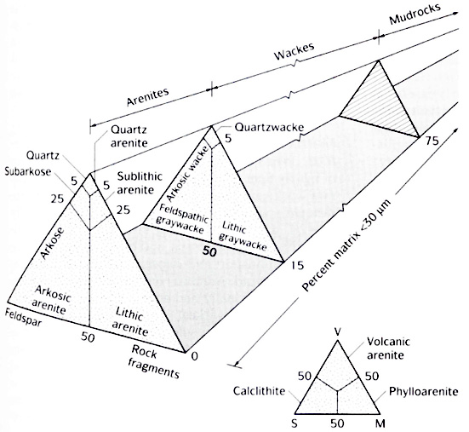

Dott’s (1964) Classification of Sandstones.

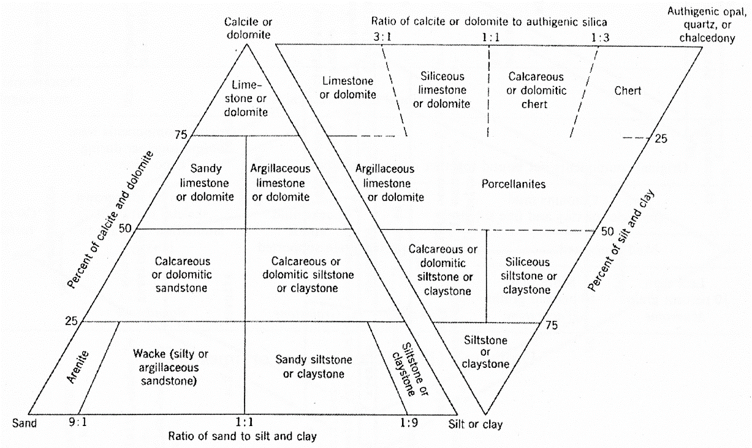

Rock names for various sedimentary components. Note that sand, silt, and clay do not include detrital grains of calcite or dolomite. Modified after Williams et al. (1954).
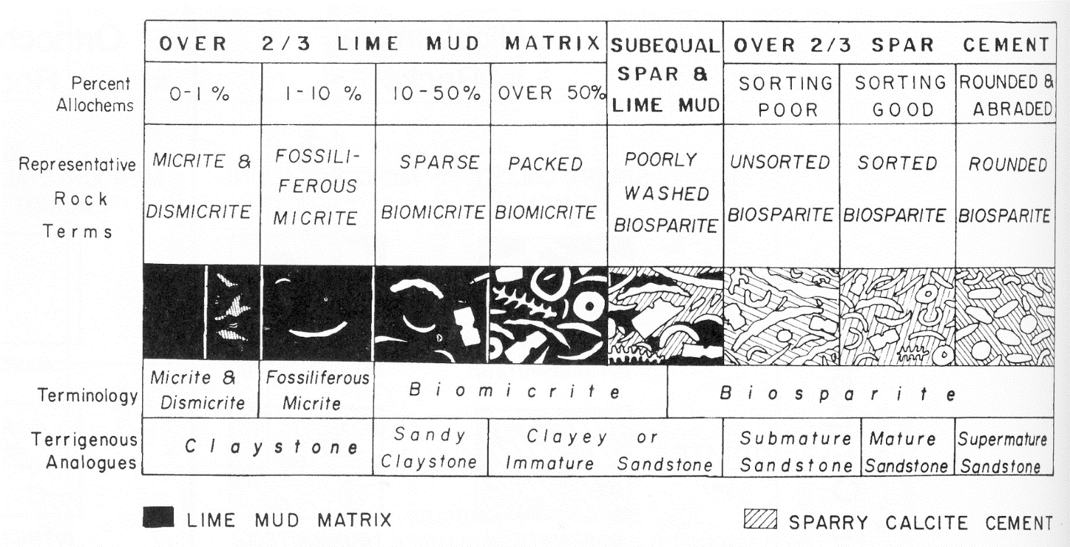

Folk’s (1962) classification of limestones.

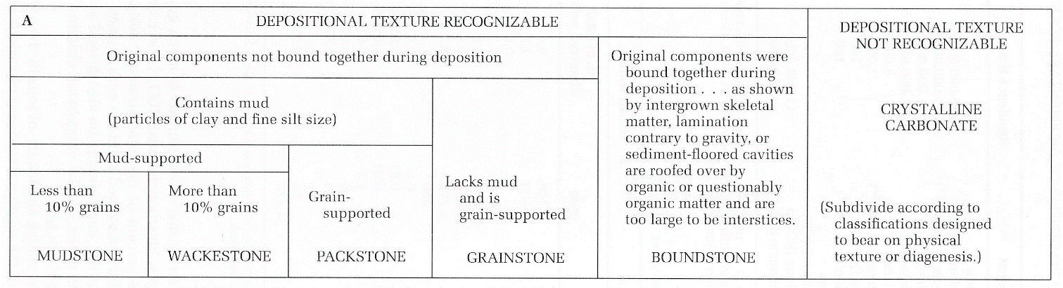

Dunham’s (1962) classification of limestones.
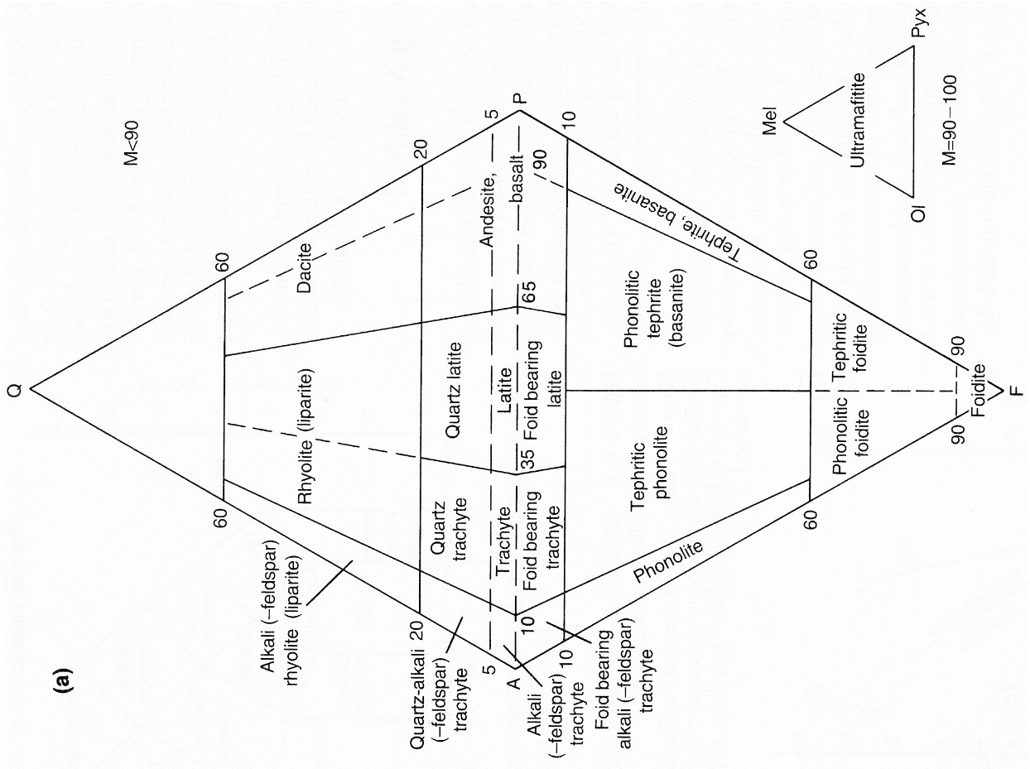
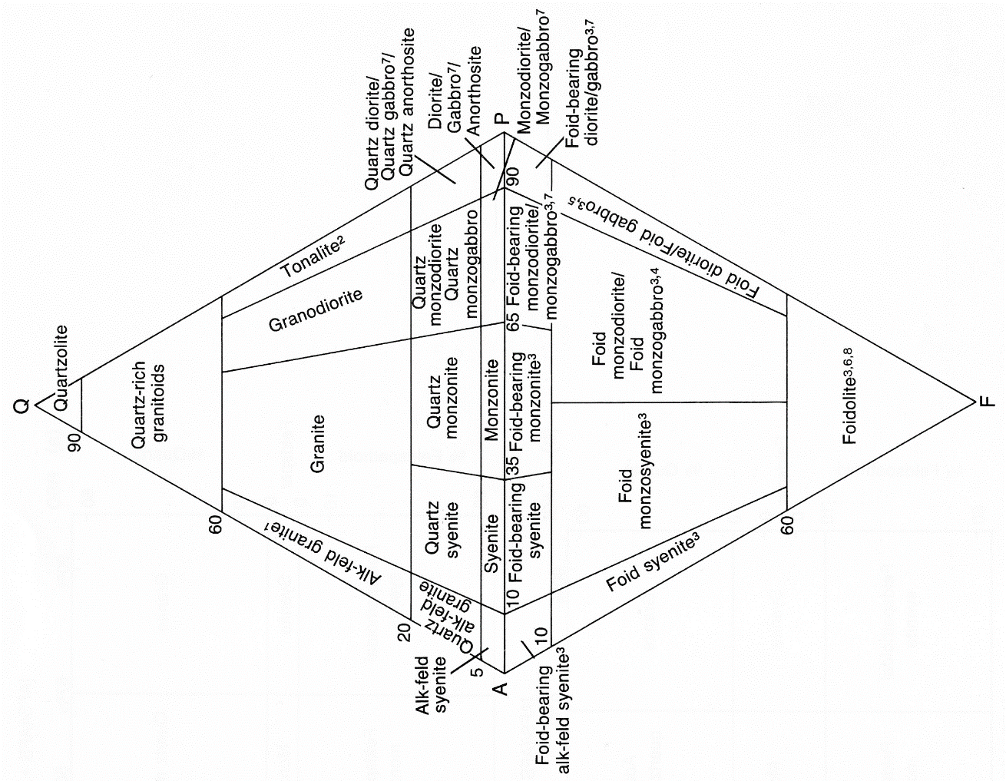
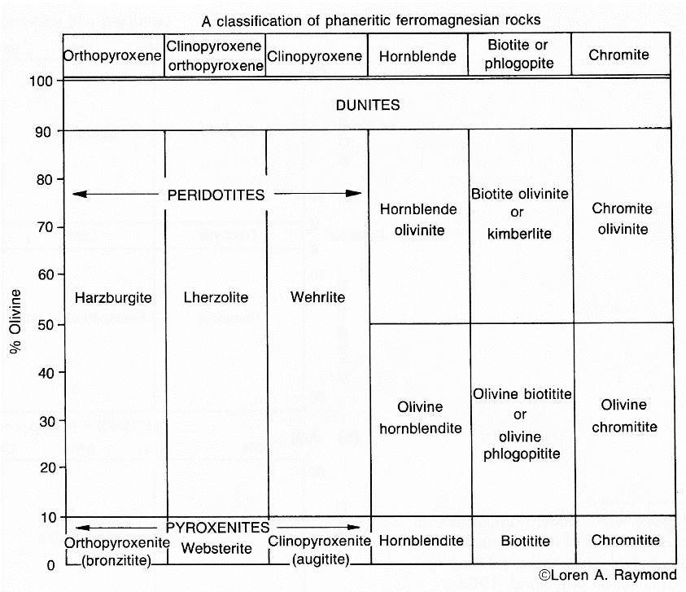
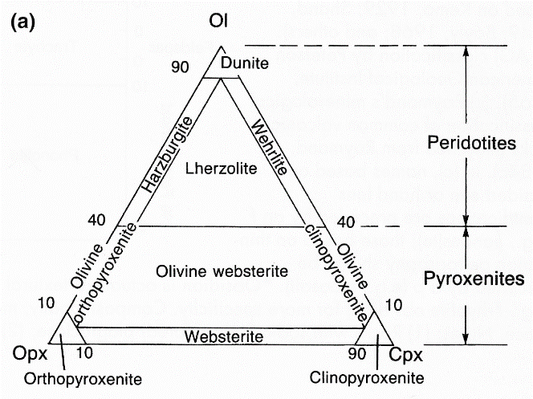

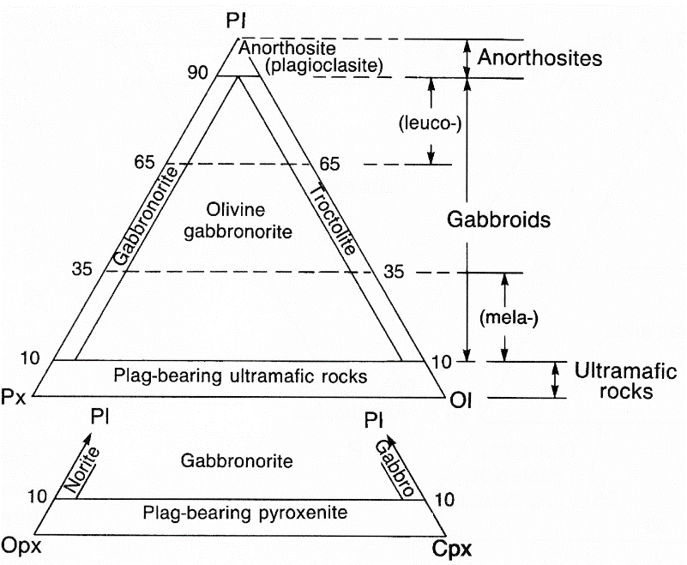
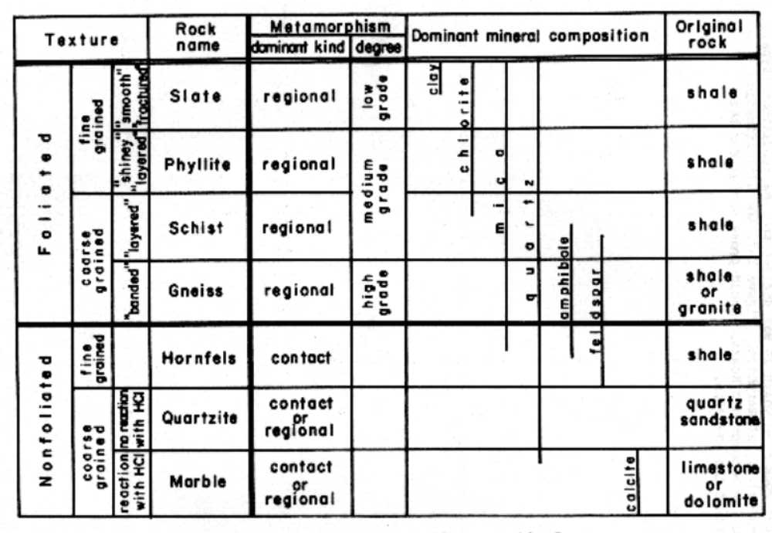

Generic classification scheme for metamorphic rocks.
Measuring Stratigraphic Section

We measure stratigraphic sections to acquire basic, fundamental geologic information. Observations and numerical data collected while measuring a section can be useful in a wide variety of geological subdisciplines, including at least: sedimentology, structural geology, and paleontology. Measuring a stratigraphic section may help a geologist establish the stratigraphic position and characteristics of marker horizons that will assist in mapping a region. Measuring a section may facilitate stratigraphic correlations by establishing the age or lithologic properties of units in an area. Measuring a stratigraphic section may have structural significance because it may allow us to recognize deformation-induced thickening or thinning of stratigraphy. Measured sections can provide detailed information about lithologic facies, thereby facilitating an analysis of regional or local depositional history or environments.
The best place to measure a stratigraphic section is where the rocks are very well exposed. Complete exposure and easy access are two of the most important considerations when choosing where to measure a stratigraphic section. The next choice in deciding where to measure a stratigraphic section depends in part on one's purpose for measuring it. If your goal is simply to find the true depositional thickness of a unit or units, then the section must be measured in an area free of significant deformation that could alter original stratigraphic thicknesses. If, however, you seek to recognize tectonic thickness changes, then you must measure both an undeformed stratigraphic section and one or more deformed sections. It is only by having an undeformed thickness of the rocks that you can recognize stratigraphic sections that have been thickened or thinned.
Measuring stratigraphic sections is an inherently imprecise process and there are many sources of errors. Mistakes measuring strikes and dips, measuring lengths, shooting bearings, or measuring slope angles are all compounded when you measure a section. Because of this, and because the original, depositional thickness of stratigraphic units can change over a region, it is wise to always include an estimate or calculation of the error in your final measurements. It is very unlikely that a unit will be exactly 111 m thick. It is more realistic that the unit is 110 ± 5 m thick.

Measurement Techniques
Figure A1-1 shows the general variables involved in measuring the thickness of layered rocks. Note that T is the true thickness of the rocks, and can only be measured in a plane normal to bedding strike. It is possible to measure layer thickness along some line or in a plane that is not normal to strike, but corrections must be made to your "apparent thickness" measurements when this is done.
There are a wide variety of methods available for measuring stratigraphic sections. Each of them can be adapted to the particular environment in which you are operating. In general, the more precise the method, the more time consuming it is.

Compass and Tape Methods
Figure A1-2 shows an example of how to measure a stratigraphic section using a compass and measuring tape. This method can be subdivided into several general steps:
1. Measure the strike and dip (δ) of rocks in the section of interest.
2. Extend a measuring tape parallel to the dip direction of the rocks and across the outcrop width of the section of interest. If the section is longer than your tape, you will have to proceed in several increments.
3. Measure the slope distance s for the interval of interest.
4. Determine the slope angle (σ) by sighting up and down the tape.
5. Calculate the true thickness from:

use +σ when the slope and bedding dip in opposite directions and -σ when they dip in the same direction

Note that there are several important sources of error that can creep into sections measured in this manner.
• error in measuring s, δ or σ
• changes in δ or σ that might occur over the length of your measured interval
• misorientation of your traverse so it is not perpendicular to strike

Hewett (1920) Method
This method eliminates the need to measure the surface slope length (s), and slope dip (σ), and thereby increases the speed which with a section can be measured. In place of these two parameters, the Hewett method requires the geologist to determine their eyeheight (E), and use this distance as a unit measuring length to calculate section thicknesses. After measuring her eyeheight, the vertical distance from the ground to their eyes, a geologist can make fairly rapid measurements of stratigraphic thicknesses in the following manner:
1. Measure the strike and dip (δ) of rocks.
2. Set the compass inclinometer to this dip angle.
3. While looking in the direction of a traverse line perpendicular to bedding strike, site through the compass to some point on the ground that lies along the traverse line (Figure A1-3).
4. Move to the newly sited position and record one eyeheight of measured stratigraphic thickness
5. Repeat steps 1-4 until reaching the end of the section of interest. Since a section is unlikely to be an integer number of eyeheights or staff heights, the geologist will commonly have to estimate the fractional component of the section he or she last encounters.
6. After traversing the section of interest, calculate the section thickness (T) using:

,

where n is the number of eyeheights it took to traverse the section, E is the eyeheight of the measuring geologist, and δ is the dip of the rocks.

Note that when measuring sections by the Hewett (1920) method, geologists must be careful to exactly occupy each station they successively site to, and they must also carefully adjust for changes in dip (δ), that might occur between the top and bottom of the measuring interval. In practice, a geologist will first determine the dip of rocks in the area to be measured. Using this dip, one would then insert n=1 into the equation above and determine the number of feet of section for each eyeheight of the measuring geologist. By doing this, one will immediately know for each eyeheight, how many feet of section one has measured; no later conversion is necessary and one can log the section much more efficiently.

Mertie (1922) Method
It is often impossible to conduct a traverse perpendicular to the strike of the section of interest. In these circumstances, when the geologist can follow a straight-line, strike-oblique traverse, another geometric parameter enters into the equations for calculating section thickness. This new parameter is the acute angle (α) between the line of strike of the section of interest, and the trend of the traverse line (Figure A1-4).
When calculating section thickness in this way, we must know four geometric parameters, the slope length (s), the slope dip (σ), the bedding dip (δ) and the traverse trend (α). When these numbers are known, the section thickness (T) can be calculated from:

As in the compass and tape methods, the (+) sign is used when the slope and bedding dip in opposite directions, and the (-) sign is used when they dip in the same direction. Note that when the traverse is perpendicular to strike (i.e. α = 90˚), this equation reduces to the simple equation given under Compass and Tape Methods.
The Mertie (1922) method can also be modified and combined with the Hewett (1920) method to create a rapid technique for measuring section thickness along a straight-line strike-oblique traverse. To do this, one would set the compass clinometer to the apparent dip of bedding observed along the traverse line and then sight each new position along the strike-oblique traverse using this apparent dip angle. The number of eyeheights (E) along the traverse are counted accordingly and used in the equation given under Hewett's method. Note, however, that you must still use the true dip (δ) in the equation for calculating section thickness.

Practical Field Procedures When Measuring Stratigraphic Sections
The items in the list below should be incorporated in your field notes when you are measuring stratigraphic sections. Remember that you should draw a balance between the detail of your description and your purpose for measuring the section. For example, you need not describe variations that occur on the scale of centimeters if your main purpose for measuring a section is to establish for mapping purposes, the aggregate thickness of a formation whose thickness is 100 m. In this case, you need to accurately establish the total formation thickness, the variation in total thickness, and the internal variations in the formation that may help you identify it in the field and which may be large enough to appear on the scale of your map.

1. Title: Include the formation(s) measured, the geographic location, and the method of measurement. If you are using eyeheight, record your eyeheight as the standard used.

2. Starting and Ending Points: use either a stratigraphic top or bottom as the starting and/or ending points of your measured section. Give a geographic description of both the starting and ending points, making sure your description is sufficient to permit others to find the place where you measured your section and therefore follow your work. Stratigraphic limits, such as adjacent formations, alluvium, hilltops, covered intervals, etc., should be indicated at the proper places in the section.

3. Attitude of Beds: If the attitude is uniform, it should be stated in the heading, otherwise, the attitude of a bed or group of beds should be indicated at the appropriate places in the section. Even if the attitude seems uniform, make sure to measure and be certain; dip changes of only a few degrees can cause significant errors in your thickness measurements.

4. Unit Numbers: Each described unit should be given a number, in serial order. It does not matter whether Unit 1 is the oldest or youngest bed in the section.

5. Unit Descriptions: Provide a complete description of each unit in your section. See the section titled “Field Description of Rocks,” in Appendix 1 for some guidelines on what to include in your rock descriptions. Your description should include at least the following:
• type of rock (e.g. ss, sh, ls, dol, mudst)
• color of fresh and weathered surfaces
• texture (grain size and character, sorting, porosity or density)
• mineralogy
• bedding (thickness of bed or laminae, geometry of beds, continuity)
• outcrop description (cliff former, slope former, ledges, rounded knobs, etc.) Often it is best to indicate this characteristic with a small diagrammatic profile in the margin of your notebook.
• other features such as fissility, cementation, concretions, vugs, veins, organic content, and fossils
• relation to enclosing beds (e.g. sharp contact, gradational contact, unconformity)

6. Side Stepping and Traverse Maps: Remember that you can pass obstacles along your section line by "side-stepping," or moving laterally along strike at the same stratigraphic position, and then continuing along with your strike-normal traverse. If you do this, or if your traverse is anything but a straight line, you should include a map of your traverse, indicating where you side-stepped or altered the course of your traverse. Show the length of each straight section of the traverse, as well as the bearing of the traverse line.

7. Data Table: Keep your data organized and spatially related in your notebook. It will be easier to reconstruct what you did if you keep your data in some sort of table that associates your observations with your measurements of thickness, bedding orientation, traverse trend, etc. Begin at the bottom of each pair of pages and work your way to the top of a page. Because we usually measure sections from bottom to top, this will keep your notes in proper stratigraphic order, with older rocks at the bottom and the beginning and bottom of your notes, and younger rocks at the top and end of your notes. The diagram below is an example of how to lay out your field notebook when measuring stratigraphic sections. Think of the diagram as spreading across two facing pages of your notebook. Unit numbers and their corresponding descriptions go on the left-hand page of your notebook, whereas the graphic representation of the column, along with strike and dip and traverse bearing data all go on the facing, right-hand page. Leave some space along the far right edge for notes about sidestepping, the difficulty of the terrain, and other things like who was doing the measuring, etc.
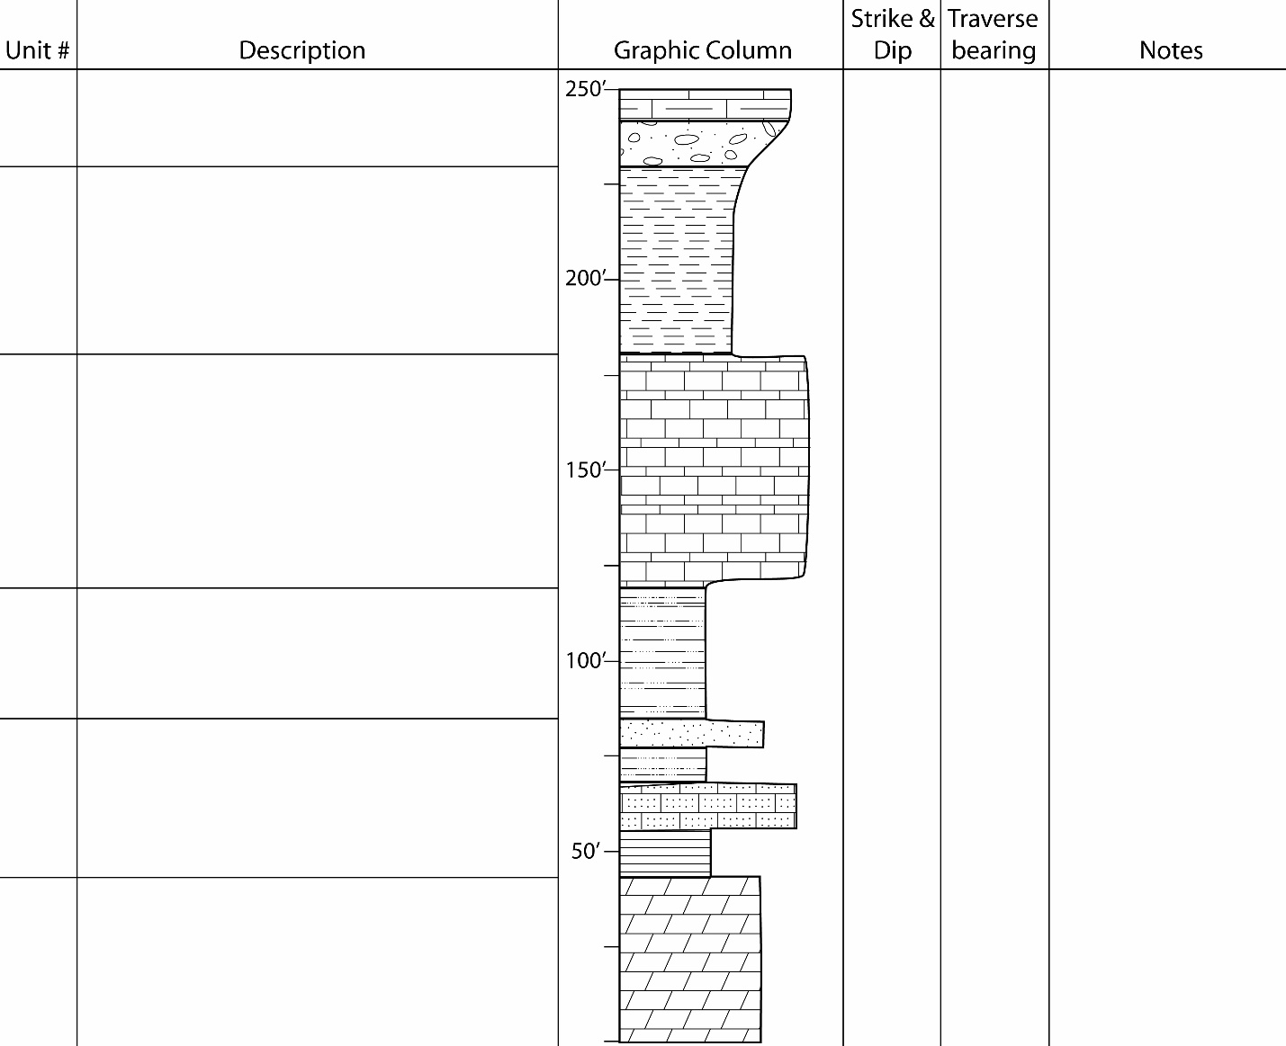

Binding of field notebook
Example layout of your field notebook when measuring stratigraphic sections.
(eg., strike &dip, traverse bearing,
Obstacles or complications in traverse
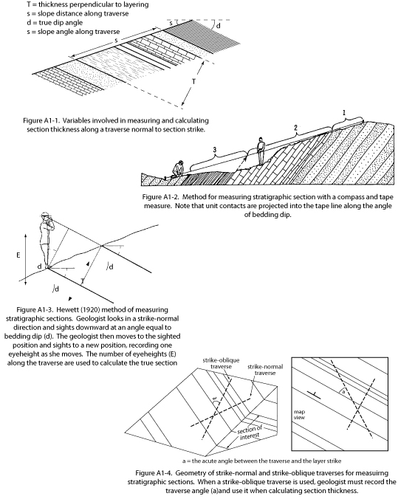
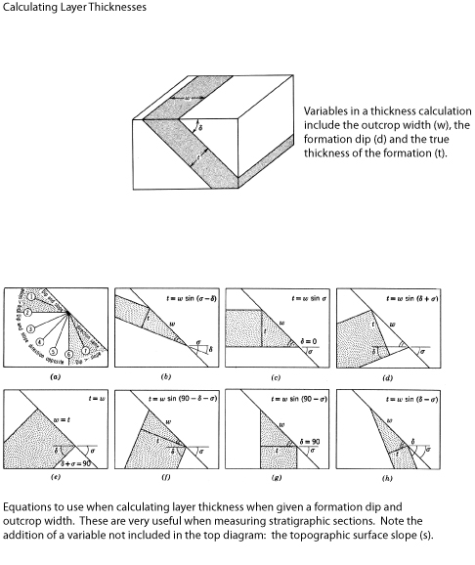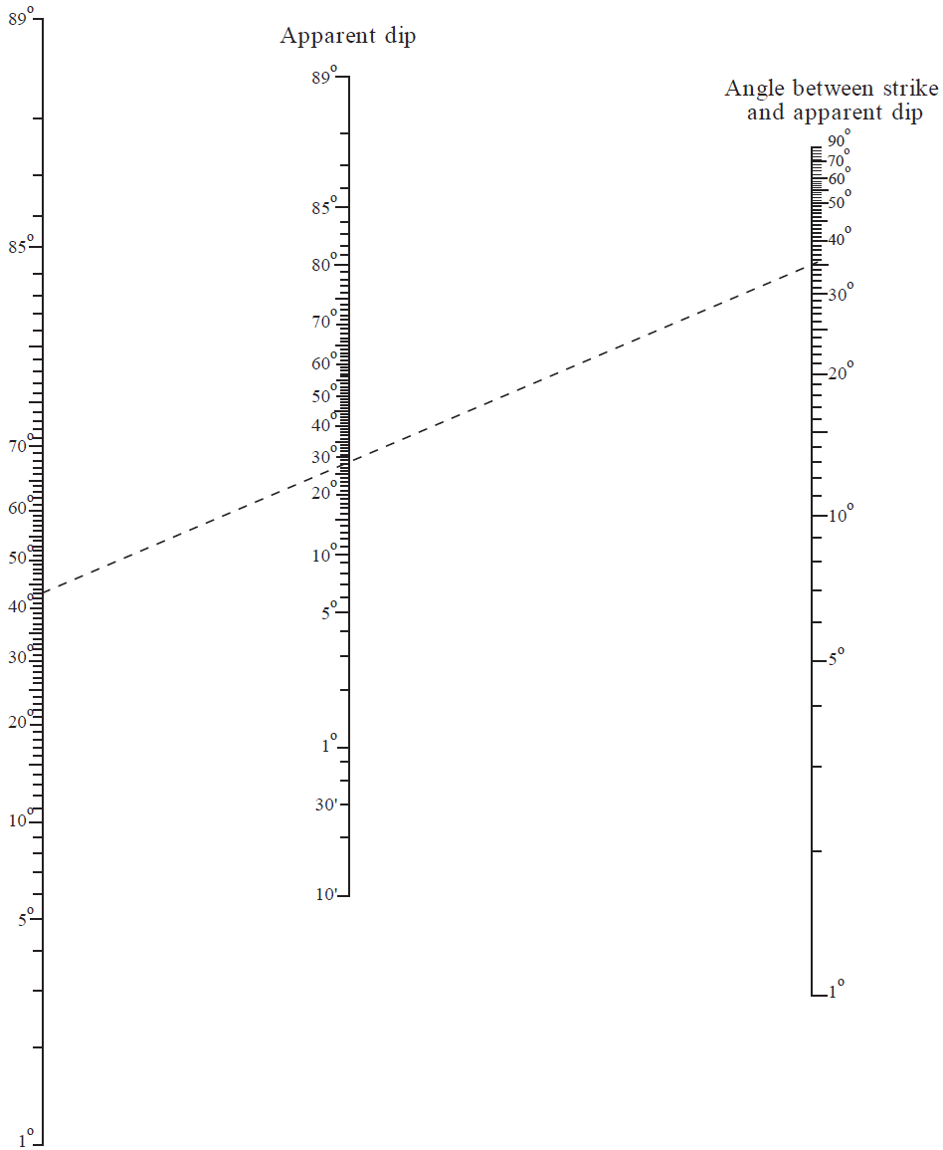
True dip

Alignment diagram (nomogram) for use in solving apparent-dip problems. After Palmer (1918).
Place a straight edge on the two known values to determine the unknown value. As shown on the diagram, if the true dip of a plane is 43º and the angle between the strike and the apparent dip direction is 35 º, then the apparent dip is 28 º.
Calculating Strike and Dip of a Surface from Contacts on a Map

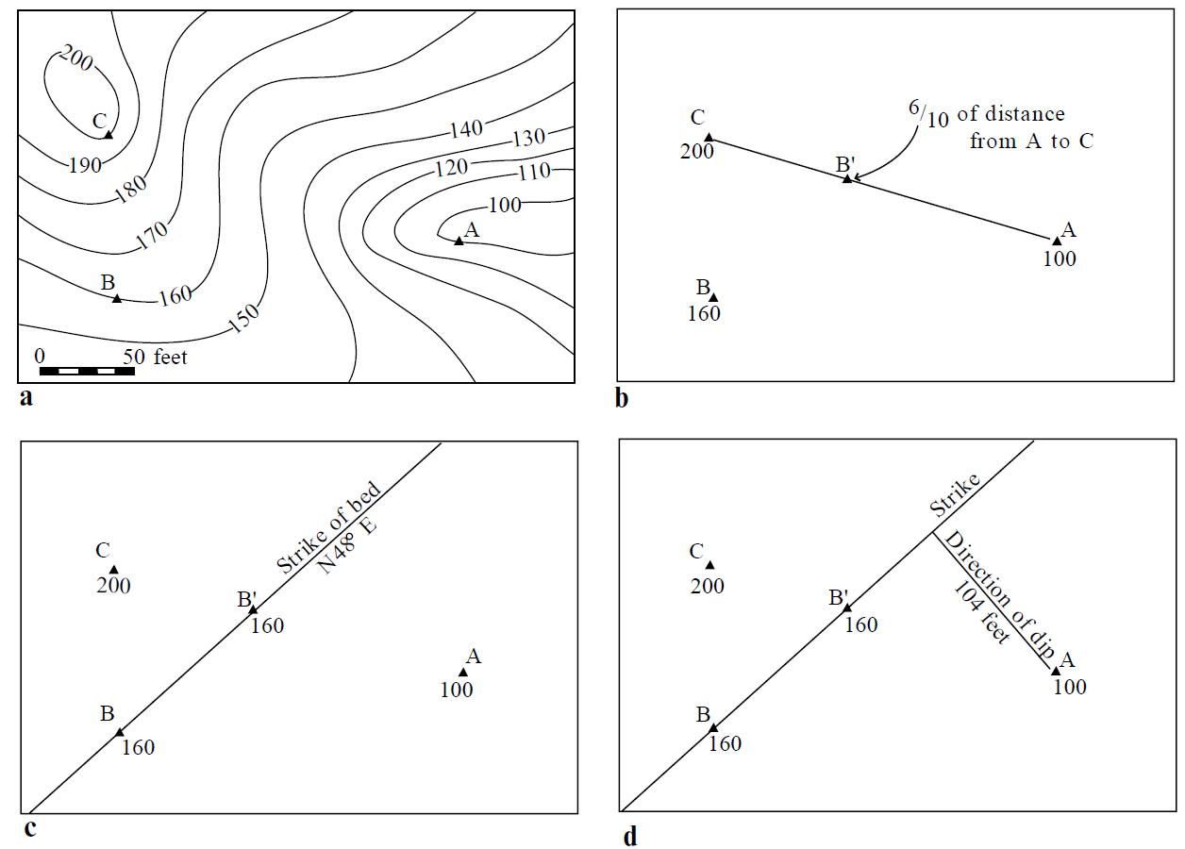

Follow the above four steps to use a three-point problem to determine the attitude of a homoclinally dipping surface. (a) Locate three points (A,B,C) that lie on th esurface, but which crop out at different elevations. (b) Draw a line connecting the points at the hightest (C) and lowest (A) elevations and find a new point (B’) along that line that has the same elevation as your third map point (B). (c) Draw a line connecting points B and B’, this is the line of strike for the surface. The value of the strike can be measured with a protractor. (d) Draw a lineperpendicular to the strike line and through the lowest identified point on the surface. (A). Mearure the length of this line using the map scale and then calculate the dip of the surface by dividing the elevation between A and B by the length of the line you just drew (i.e. rise over run). The dip of th esurface is the inverse tangent of the qoutient you just obtained. The dip direction is from the line of the strike toward the lowest identified point (A).
Calculating Outcrop Patterns from Field Observations – Constructing a Map

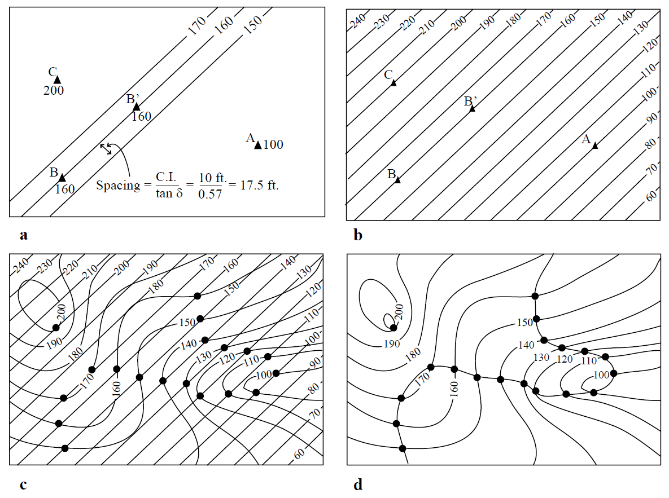

You can construct a geologic map or simple outcrop pattern of homoclinally-dipping rocks by finding the intersection lines between the surface topography and the formation contacts in the region. (a) Conduct a simple three-point problem to find the strike and dip of the surface of interest. Draw in the line of strike and after picking a useful contour interval, determine the horizontal distance between structure contours that would occur on the surface. The spacing is given by the contour interval divided by the tangent of the surface dip. (b) Draw in equally-spaced ctructure contours that cover the entire map area. (c) Place the structure contour map over or under the contours that have equal elevations. (d) Connect the dots to make a continuous line marking the intersection of your surface and the topography.

Calculating Outcrop Patterns from Field Observations – Constructing a Map

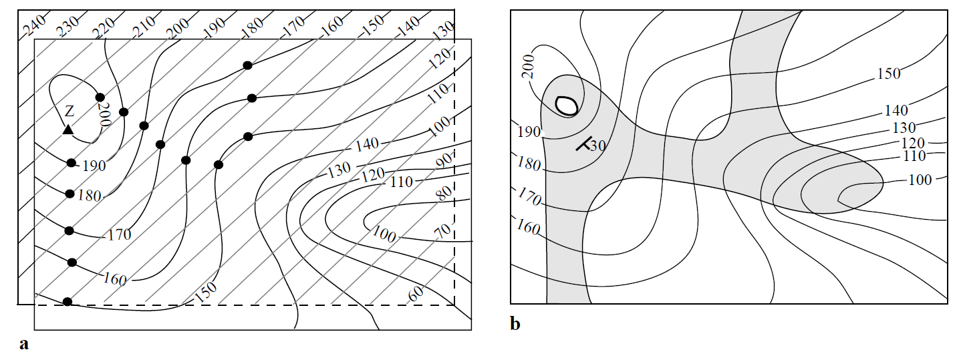

To create the outcrop pattern of the bottom of the formation you simple move the struction contour map and repeat steps (a) through (d) for the new surface. (e) Find a point (Z) at the bottom of the formation and re-register the structure contour map at that point, with the structure contour lines parallel to the local strike of the surface. (f) Connect the dots marking the intersection between the surface topography and the formation bottom. Color in the formation and you’re done.

Remember that you cannot do this simple contruction method if the layer changes thickness significantly or if it significantly changes strike or dip over the region of the construction. However, if you can construct structure contours on complex structural surfaces such as folded rock layers, where strike and dip change over the map area, you can still contruct a map with this method. In that case your structure contour map will look something like a topographic map, rather than a series of straight, parallel lines.

Appendix 2:
General Guidelines for Map Preparation

The following is a list of guidelines useful in preparing geologic maps. Before submitting a project, make sure your map abides by all these guidelines. If it does, you will get a better grade.

Contacts and Symbols
• use a different symbol to indicate the confidence of your contact interpretation
- solid lines mean you know exactly where the contact is located and should be accurate to within 1-2 ft.
- dashed lines mean you an only approximate where the contact is located, and should be accurate to within 20-30 ft. (often you can state the limits of accuracy here as geologists do not necessarily agree)
- dotted lines mean a contact is covered, for example, by alluvium, and its location is therefore only inferred
• the use of dashed or dotted lines is appropriate for any feature that appears as a line on the map, for example, if you can only approximate the location of a fault, draw that fault as a dashed line
• strike and dip symbols should be drawn so that the center of the symbol lies exactly at the point where you took the measurement

Explanation
• every map should have an explanation section that includes:
1. your name and the date
2. the names of your partners for the project
3. index boxes for each stratigraphic unit observed in the area or shown on the cross section
- write the age and formal name of the unit next to the corresponding box
- put the formal unit abbreviation in the box
- color each box a unique color that matches the color used for that unit on the map
- arrange the boxes in proper stratigraphic sequence, with the youngest at the top and oldest at the bottom
4. the map scale in text and graphically, as a scale bar
5. the map contour interval, for example C.I. = 20 feet
- because some of our projects use two or more maps “pasted” together, the contour interval may be different in different sections of your base map. If this is so, you will want to indicate the different contour intervals, as well as where on the map they apply
6. All symbols used on either the map or section (e.g., strike and dip, fold axes, contacts, faults)
7. a brief title such as “Map and Cross Section Explanation”

Geologic Reality
• make sure your map is geologically reasonable
- don’t violate the laws of physics or geology (e.g., stratigraphic sequences must be maintained, faults don’t have reverse displacement at one point and normal displacement at another, etc.)
Other Examples:
• faults should exhibit geometries similar to those observed regionally (e.g. don’t interpret a low angle thrust fault if the tectonic style of the region is dominated by high angle normal faults). If you do make a radically different or new interpretation, you’d better be able to support it with your field observations!
• intrusions should exhibit geometries similar to those observed regionally
• local strike of sedimentary bedding is almost always parallel to contacts between conformable units
• obey the rule of V’s

Outcrop Widths and Unit Thicknesses
• although unit thicknesses are relatively uniform throughout a map area of the size we typically work with, the horizontal width of an outcrop belt measured perpendicular to the contacts (i.e. the outcrop width) is not constant.
- outcrop width depends on unit thickness, unit dip, and the dip of surface topography, the last two of which can vary significantly throughout even a small map area
- there are explicit relations between these parameters that must be obeyed if your map is to be geologically reasonable
- for simple horizontal topography, outcrop width equals unit thickness divided by the sine of the unit’s dip angle)
• be sure your unit thicknesses fall within the known limits for the region

Presentation Style and Grace
• a part of every grade is attributed to the overall aesthetic appeal of your map
• consider the following questions before you hand in your section (perhaps even before you start it!)
- did you color evenly?
- is your lettering neat and legible?
- is the layout graphically economic?
- is information organized so that users can quickly find whatever they need (e.g., the scale or a symbol definition, etc.)
Appendix 3:
Essential Analysis Tools and Cross Section Construction

The following is a list of guidelines to be used in preparing geologic cross sections. Before submitting a project, make sure your cross section abides by all these guidelines. If it does, you will most likely get a better grade.

Apparent Dip Data
• show the location and orientation of all the strike and dip data you projected into the plane of your section.
- illustrate apparent dip values using “tadpoles” whose heads lie on the topographic profile, and whose tails dip in the appropriate direction at the appropriate apparent dip angle.

Geologic Reality
• this is the most difficult part of section construction, and where your understanding of geology and how to extrapolate into the subsurface is most important
- developing and refining these extrapolation skills is an essential part of this course!
• there are few, if any, “absolutely right” answers in field geology, but the idea in section construction is to use the surface data (i.e. your field observations compiled on your map and in your notes) as the basis for a subsurface interpretation
- if your interpretation does not violate the laws of physics and geology, matches the surface outcrop data exactly, and is compatible with what we know about the regional geology (e.g., igneous, tectonic and metamorphic history and style), then your section is just as “right” as any other section that abides by the same constraints.
- geologists are constantly arguing over which interpretation is “best”, but, there should be no arguing over where a contact lies on the map, whether that contact is located in the right place on your section, or the orientation of bedding at a certain location.
• how to make sure your section is geologically reasonable?
- don’t violate the laws of physics or geology (e.g., stratigraphic sequences must be maintained, faults don’t have reverse displacement at one point and normal displacement at another, etc.)
- other things to check include
1. contacts on your section must be accurately located so that they exactly match your map
2. unit thicknesses must be kept uniform (see below)
3. interpret only natural fault and fold geometries
4. cross sections must exactly match at intersection points

Presentation Style and Grace
• a part of every grade is attributed to the overall aesthetic appeal of your section
• consider the following questions before you hand in your section (perhaps even before you start it!)
- did you color evenly and lightly?
- is your lettering neat and legible?
- is the layout graphically economical?
- is information organized so that users can quickly find whatever they need (e.g., the scale or a symbol definition, etc.)
- are all words spelled correctly?
- are geologic units in the Explanation in the proper age order?
- are all map and cross-section symbols shown in the Explanation?

Scale
• every cross section must have a vertical and horizontal scale, written in text, and illustrated graphically along the sides of the section.
• if the vertical and horizontal scales are equivalent, note it on the section. If they are not, write out the vertical exaggeration that was used.
- an example scale would be 1 : 50,000. Note that this scale indicates 1 unit on the section represents 50,000 equivalent units in the real world.
- the correct separator between the two parts of the scale is a colon (:), not an equal (=) sign

Section Endpoints
• label each end of the cross section according to the corresponding endpoints of the section line on the map
- for example, label ends A and A’, B and B’, etc.
- often it is also a good idea to label the compass direction of each end of the section, for example, N and S, or NE and SW.

Section Intersection Points and Bends
• if your section crosses another section line, label the intersection between the two sections on each of the two sections.
- this is usually done with an arrow drawn slightly above the topographic profile and some adjacent text noting for example, “intersection with B-B’”.
• if your section bends, label the point at which it bends.
- this is usually done with an arrow drawn slightly above the topographic profile and some adjacent text noting for example, “bend in section”.

Topographic Profile
• your cross section must accurately show the topography along the section line

Units Labeled and Colored
• each formal stratigraphic unit should be colored to match your map
• each formal stratigraphic unit should be labeled with the formal abbreviation for the map unit
- if the label won’t fit, draw it nearby and draw an arrow from the label to the corresponding unit

Unit Thicknesses
• is the thickness of a given unit uniform throughout the area?
- unless you have direct evidence to the contrary, the thickness of each unit should be uniform throughout your cross section
• are the unit thicknesses within the range of known thicknesses in the area?
- if your section thickness is significantly thicker (e.g., 10-20%) than the known greatest thickness in the region, chances are, you’ve made a mistake. The same is true if your thickness is significantly less than the known minimum thickness in the region.
• is the thickness consistent with the mapped outcrop width and measured dip?
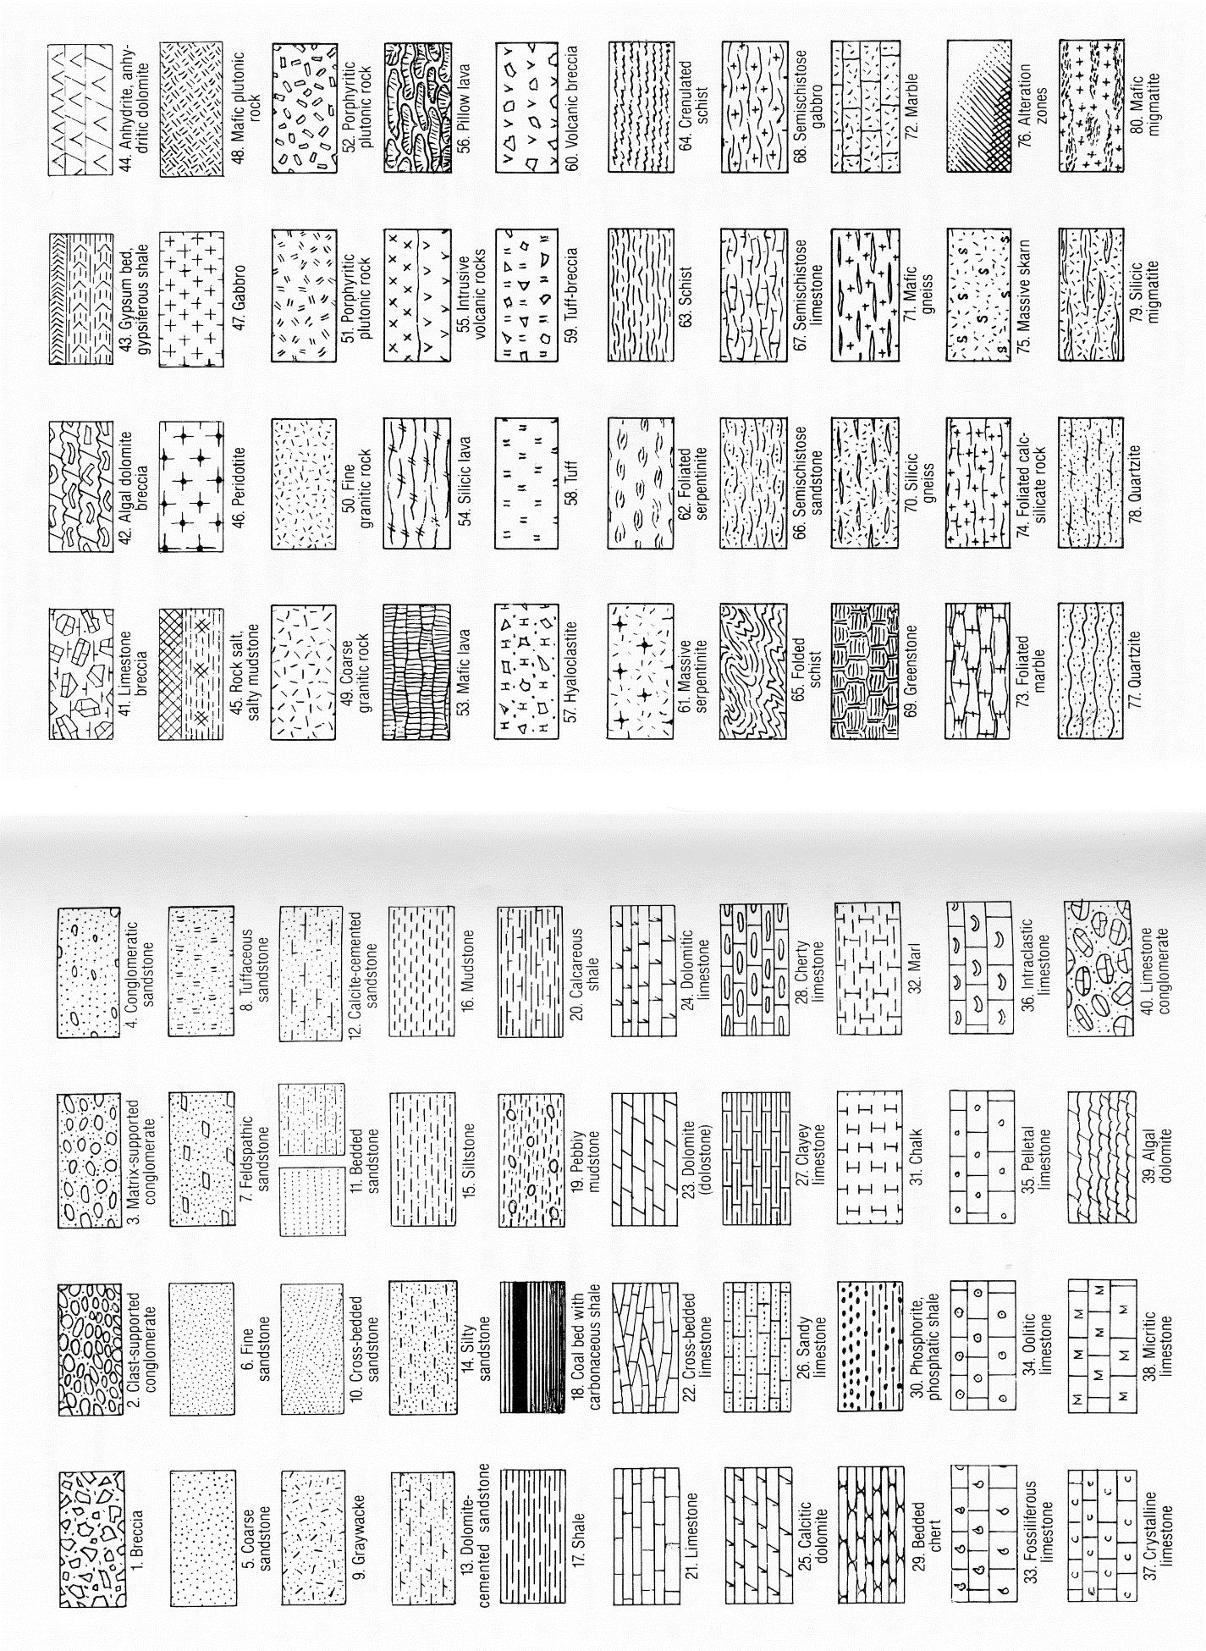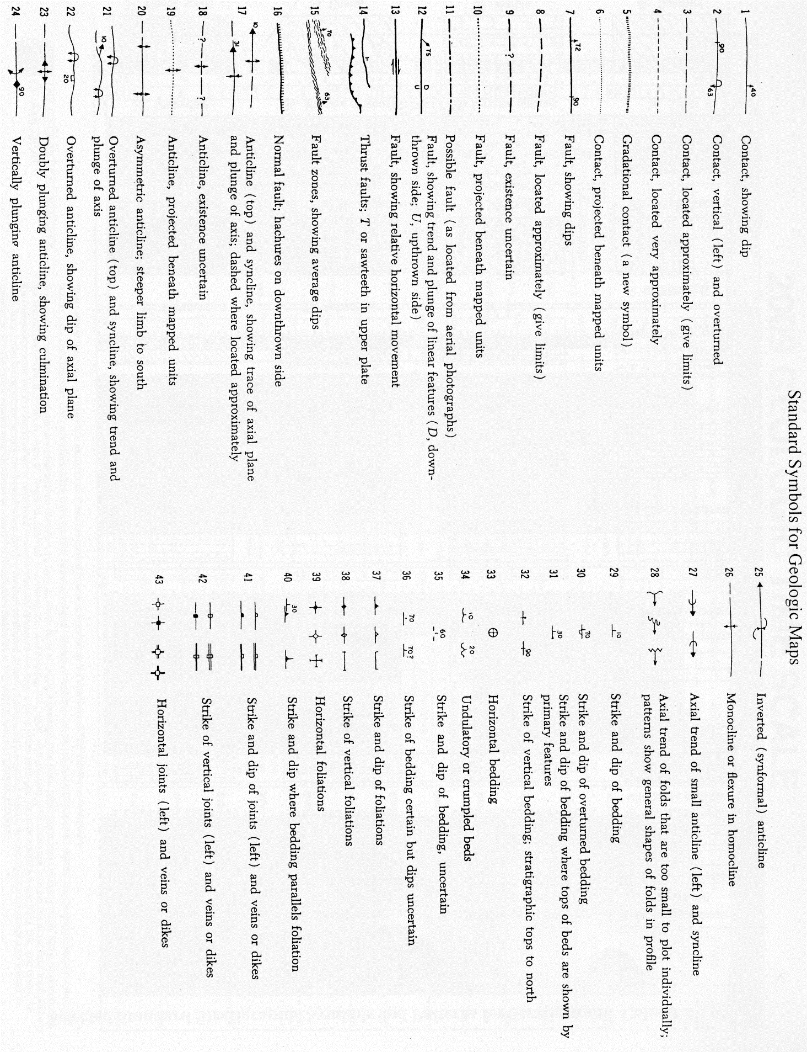
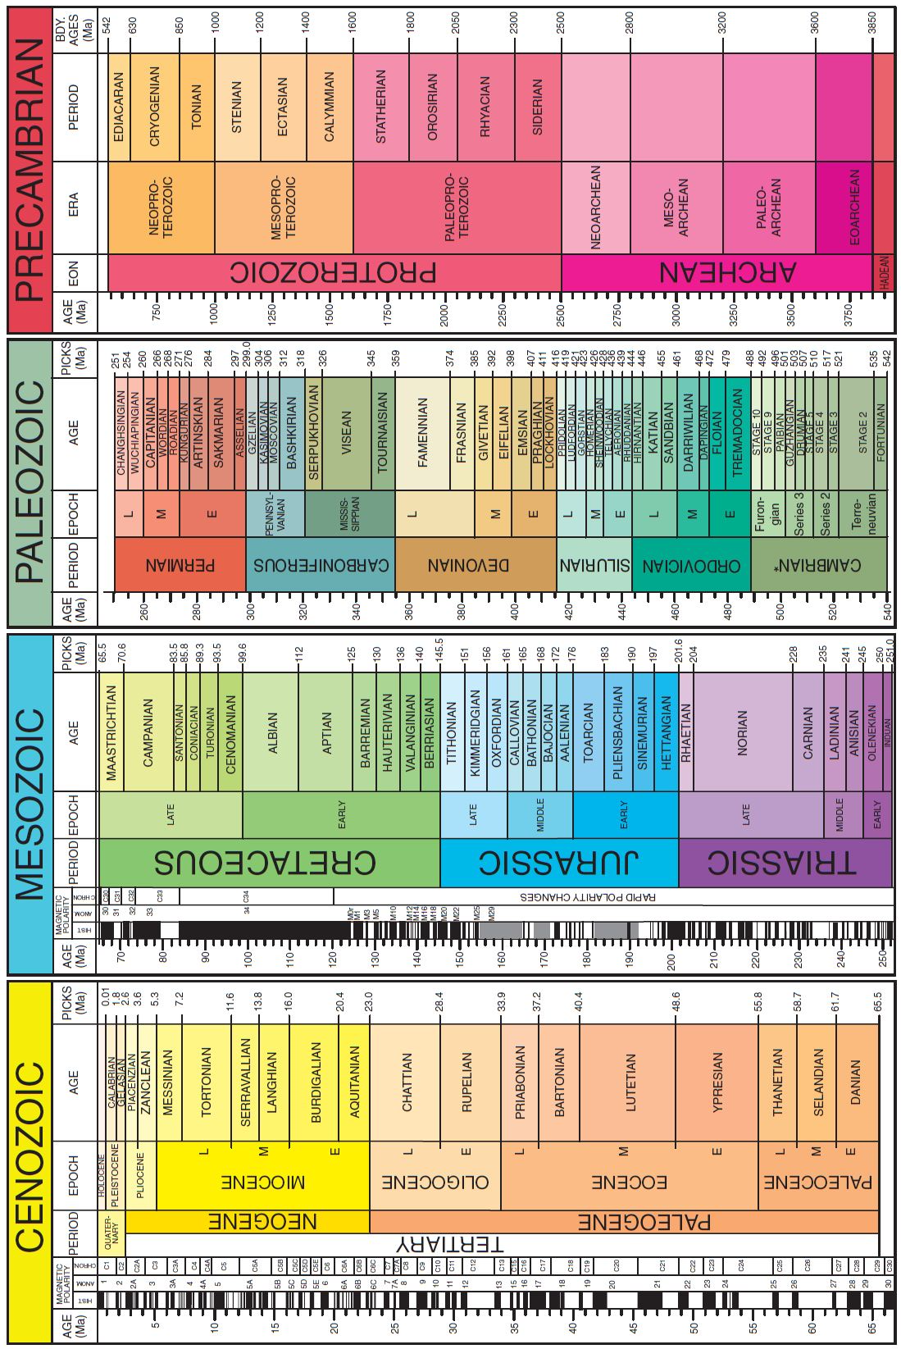

Anaphylaxis: First aid

A life-threatening allergic reaction (anaphylaxis) can cause shock, a sudden drop in blood pressure and trouble breathing. In people who have an allergy, anaphylaxis can occur minutes after exposure to a specific allergy-causing substance (allergen). In some cases, there may be a delayed reaction or anaphylaxis may occur without an apparent trigger.
If you're with someone having an allergic reaction with signs of anaphylaxis:
- Immediately call 911 or your local medical emergency number.
- Ask the person if he or she is carrying an epinephrine autoinjector to treat an allergic attack (for example, EpiPen, Twinject).
- If the person says he or she needs to use an autoinjector, ask whether you should help inject the medication. This is usually done by pressing the autoinjector against the person's thigh.
- Have the person lie still on his or her back.
- Loosen tight clothing and cover the person with a blanket. Don't give the person anything to drink.
- If there's vomiting or bleeding from the mouth, turn the person on his or her side to prevent choking.
- If there are no signs of breathing, coughing or movement, begin CPR. Do uninterrupted chest presses — about 100 every minute — until paramedics arrive.
- Get emergency treatment even if symptoms start to improve. After anaphylaxis, it's possible for symptoms to recur. Monitoring in a hospital setting for several hours is usually necessary.
If you're with someone having signs of anaphylaxis, don't wait to see whether symptoms get better. Seek emergency treatment right away. In severe cases, untreated anaphylaxis can lead to death within half an hour. An antihistamine pill, such as diphenhydramine (Benadryl), isn't sufficient to treat anaphylaxis. These medications can help relieve allergy symptoms, but work too slowly in a severe reaction.
Signs and symptoms of anaphylaxis include:
- Skin reactions including hives, itching, and flushed or pale skin
- Swelling of the face, eyes, lips or throat
- Constriction of the airways, leading to wheezing and trouble breathing
- A weak and rapid pulse
- Nausea, vomiting or diarrhea
- Dizziness, fainting or unconsciousness
Some common anaphylaxis triggers include:
- Medications
- Foods such as peanuts, tree nuts, fish and shellfish
- Insect stings from bees, yellow jackets, wasps, hornets and fire ants
If you've had any kind of severe allergic reaction in the past, ask your doctor if you should be prescribed an epinephrine autoinjector to carry with you.

Blisters: First aid

If a blister isn't too painful, try to keep it intact. Unbroken skin over a blister provides a natural barrier to bacteria and decreases the risk of infection. Cover a small blister with an adhesive bandage, and cover a large one with a porous, plastic-coated gauze pad that absorbs moisture and allows the wound to breathe. If you're allergic to the adhesive used in some tape, use paper tape.
Don't puncture a blister unless it's painful or prevents you from walking or using one of your hands. If you have diabetes or poor circulation, call your doctor before considering the self-care measures below.
How to drain a blister
To relieve blister-related pain, drain the fluid while leaving the overlying skin intact. Here's how:
- Wash your hands and the blister with soap and warm water.
- Swab the blister with iodine or rubbing alcohol.
- Sterilize a clean, sharp needle by wiping it with rubbing alcohol.
- Use the needle to puncture the blister. Aim for several spots near the blister's edge. Let the fluid drain, but leave the overlying skin in place.
- Apply an antibiotic ointment to the blister and cover with a bandage or gauze pad.
- Cut away all the dead skin after several days, using tweezers and scissors sterilized with rubbing alcohol. Apply more ointment and a bandage.
Call your doctor if you see signs of infection around a blister — pus, redness, increasing pain or warm skin.
Blister prevention
To prevent a blister, use gloves, socks, a bandage or similar protective covering over the area being rubbed. Special athletic socks are available that have extra padding in critical areas. You might also try attaching moleskin to the inside of your shoe where it might rub, such as at the heel.

Cuts and scrapes: First aid

Minor cuts and scrapes usually don't require a trip to the emergency room. Yet proper care is essential to avoid infection or other complications. These guidelines can help you care for simple wounds:
- Stop the bleeding. Minor cuts and scrapes usually stop bleeding on their own. If they don't, apply gentle pressure with a clean cloth or bandage. Hold the pressure continuously for 20 to 30 minutes and if possible elevate the wound. Don't keep checking to see if the bleeding has stopped because this may damage or dislodge the clot that's forming and cause bleeding to resume. If blood spurts or continues flowing after continuous pressure, seek medical assistance.
- Clean the wound. Rinse out the wound with clear water. Soap can irritate the wound, so try to keep it out of the actual wound. If dirt or debris remains in the wound after washing, use tweezers cleaned with alcohol to remove the particles. If debris still remains, see your doctor. Thorough cleaning reduces the risk of infection and tetanus. To clean the area around the wound, use soap and a washcloth. There's no need to use hydrogen peroxide, iodine or an iodine-containing cleanser.
- Apply an antibiotic. After you clean the wound, apply a thin layer of an antibiotic cream or ointment such as Neosporin or Polysporin to help keep the surface moist. The products don't make the wound heal faster, but they can discourage infection and help your body's natural healing process. Certain ingredients in some ointments can cause a mild rash in some people. If a rash appears, stop using the ointment.
- Cover the wound. Bandages can help keep the wound clean and keep harmful bacteria out. After the wound has healed enough to make infection unlikely, exposure to the air will speed wound healing.
- Change the dressing. Change the dressing at least daily or whenever it becomes wet or dirty. If you're allergic to the adhesive used in most bandages, switch to adhesive-free dressings or sterile gauze held in place with paper tape, gauze roll or a loosely applied elastic bandage. These supplies generally are available at pharmacies.
- Get stitches for deep wounds. A wound that is more than 1/4-inch (6 millimeters) deep or is gaping or jagged edged and has fat or muscle protruding usually requires stitches. Adhesive strips or butterfly tape may hold a minor cut together, but if you can't easily close the wound, see your doctor as soon as possible. Proper closure within a few hours reduces the risk of infection.
- Watch for signs of infection. See your doctor if the wound isn't healing or you notice any redness, increasing pain, drainage, warmth or swelling.
- Get a tetanus shot. Doctors recommend you get a tetanus shot every 10 years. If your wound is deep or dirty and your last shot was more than five years ago, your doctor may recommend a tetanus shot booster. Get the booster as soon as possible after the injury.

Fractures (broken bones): First aid

A fracture is a broken bone. It requires medical attention. If the broken bone is the result of major trauma or injury, call 911 or your local emergency number. Also call for emergency help if:
- The person is unresponsive, isn't breathing or isn't moving. Begin cardiopulmonary resuscitation (CPR) if there's no respiration or heartbeat.
- There is heavy bleeding.
- Even gentle pressure or movement causes pain.
- The limb or joint appears deformed.
- The bone has pierced the skin.
- The extremity of the injured arm or leg, such as a toe or finger, is numb or bluish at the tip.
- You suspect a bone is broken in the neck, head or back.
- You suspect a bone is broken in the hip, pelvis or upper leg (for example, the leg and foot turn outward abnormally).
Don't move the person except if necessary to avoid further injury. Take these actions immediately while waiting for medical help:
- Stop any bleeding. Apply pressure to the wound with a sterile bandage, a clean cloth or a clean piece of clothing.
- Immobilize the injured area. Don't try to realign the bone or push a bone that's sticking out back in. If you've been trained in how to splint and professional help isn't readily available, apply a splint to the area above and below the fracture sites. Padding the splints can help reduce discomfort.
- Apply ice packs to limit swelling and help relieve pain until emergency personnel arrive. Don't apply ice directly to the skin — wrap the ice in a towel, piece of cloth or some other material.
- Treat for shock. If the person feels faint or is breathing in short, rapid breaths, lay the person down with the head slightly lower than the trunk and, if possible, elevate the legs.

Frostbite: First aid

When exposed to very cold temperatures, skin and underlying tissues may freeze, resulting in frostbite. The areas most likely to be affected by frostbite are your hands, feet, nose and ears.
If your skin looks white or grayish-yellow, is very cold and has a hard or waxy feel, you may have frostbite. Your skin may also itch, burn or feel numb. Severe or deep frostbite can cause blistering and hardening. As the area thaws, the flesh becomes red and painful.
Gradually warming the affected skin is key to treating frostbite. To do so:
- Protect your skin from further exposure. If you're outside, warm frostbitten hands by tucking them into your armpits. Protect your face, nose or ears by covering the area with dry, gloved hands. Don't rub the affected area and never rub snow on frostbitten skin.
- Get out of the cold. Once you're indoors, remove wet clothes.
- Gradually warm frostbitten areas. Put frostbitten hands or feet in warm water — 104 to 107.6 F (40 to 42 C). Wrap or cover other areas in a warm blanket. Don't use direct heat, such as a stove, heat lamp, fireplace or heating pad, because these can cause burns before you feel them on your numb skin.
- Don't walk on frostbitten feet or toes if possible. This further damages the tissue.
- If there's any chance the affected areas will freeze again, don't thaw them. If they're already thawed, wrap them up so that they don't become frozen again.
- Get emergency medical help. If numbness or sustained pain remains during warming or if blisters develop, seek medical attention.

Head trauma: First aid

Most head trauma involves injuries that are minor and don't require hospitalization. However, call 911 or your local emergency number if any of the following signs or symptoms are apparent.
Adults
- Severe head or facial bleeding
- Bleeding or fluid leakage from the nose or ears
- Severe headache
- Change in level of consciousness for more than a few seconds
- Black-and-blue discoloration below the eyes or behind the ears
- Cessation of breathing
- Confusion
- Loss of balance
- Weakness or an inability to use an arm or leg
- Unequal pupil size
- Slurred speech
- Seizures
If severe head trauma occurs
- Keep the person still. Until medical help arrives, keep the injured person lying down and quiet, with the head and shoulders slightly elevated. Don't move the person unless necessary, and avoid moving the person's neck. If the person is wearing a helmet, don't remove it.
- Stop any bleeding. Apply firm pressure to the wound with sterile gauze or a clean cloth. But don't apply direct pressure to the wound if you suspect a skull fracture.
- Watch for changes in breathing and alertness. If the person shows no signs of circulation (breathing, coughing or movement), begin CPR.

Heat cramps: First aid

Heat cramps are painful, involuntary muscle spasms that usually occur during heavy exercise in hot environments. The spasms may be more intense and more prolonged than are typical nighttime leg cramps. Inadequate fluid intake often contributes to heat cramps.
Muscles most often affected include those of your calves, arms, abdominal wall and back, although heat cramps may involve any muscle group involved in exercise.
If you suspect heat cramps
- Rest briefly and cool down
- Drink clear juice or an electrolyte-containing sports drink
- Practice gentle, range-of-motion stretching and gentle massage of the affected muscle group
- Don't resume strenuous activity for several hours or longer after heat cramps go away
- Call your doctor if your cramps don't go away within one hour or so

Heat exhaustion: First aid

Heat exhaustion is one of the heat-related syndromes, which range in severity from mild heat cramps to heat exhaustion to potentially life-threatening heatstroke.
Signs and symptoms of heat exhaustion often begin suddenly, sometimes after excessive exercise, heavy perspiration, and inadequate fluid or salt intake. Signs and symptoms resemble those of shock and may include:
- Feeling faint or dizzy
- Nausea
- Heavy sweating
- Rapid, weak heartbeat
- Low blood pressure
- Cool, moist, pale skin
- Low-grade fever
- Heat cramps
- Headache
- Fatigue
- Dark-colored urine
If you suspect heat exhaustion:
- Get the person out of the sun and into a shady or air-conditioned location.
- Lay the person down and elevate the legs and feet slightly.
- Loosen or remove the person's clothing.
- Have the person drink cool water or other nonalcoholic beverage without caffeine.
- Cool the person by spraying or sponging with cool water and fanning.
- Monitor the person carefully. Heat exhaustion can quickly become heatstroke.
Call 911 or emergency medical help if the person's condition deteriorates, especially if fainting, confusion or seizures occur, or if fever of 104 F (40 C) or greater occurs with other symptoms

Heatstroke: First aid

Heatstroke is the most severe of heat-related problems, after heat cramps and heat exhaustion. Heatstroke often results from exercise or heavy work in hot environments combined with inadequate fluid intake.
Young children, older adults, people who are obese and people born with an impaired ability to sweat are at high risk of heatstroke. Other risk factors include dehydration, alcohol use, cardiovascular disease and certain medications.
What makes heatstroke severe and potentially life-threatening is that the body's normal mechanisms for dealing with heat stress, such as sweating and temperature control, become inadequate. The main sign of heatstroke is a markedly elevated body temperature — generally greater than 104 F (40 C) — with changes in mental status ranging from personality changes to confusion and coma. Skin may be hot and dry — although if heatstroke is caused by exertion, the skin may be moist.
Other signs and symptoms may include:
- Rapid heartbeat
- Rapid and shallow breathing
- Elevated or lowered blood pressure
- Cessation of sweating
- Irritability, confusion or unconsciousness
- Feeling dizzy or lightheaded
- Headache
- Nausea
- Fainting, which may be the first sign in older adults
If you suspect heatstroke:
- Move the person out of the sun and into a shady or air-conditioned space.
- Call 911 or emergency medical help.
- Cool the person by covering with damp sheets or by spraying with cool water. Direct air onto the person with a fan or newspaper.
- Have the person drink cool water or other nonalcoholic beverage without caffeine, if he or she is able.

Hypothermia: First aid

When exposed to cold temperatures, especially with a high wind chill factor and high humidity, or to a cool, damp environment for prolonged periods, your body's control mechanisms may fail to keep your body temperature normal. When more heat is lost than your body can generate, hypothermia, defined as an internal body temperature less than 95 F (35 C), can result.
Wet or inadequate clothing, falling into cold water and even not covering your head during cold weather can increase your chances of hypothermia.
Signs and symptoms of hypothermia include:
- Shivering
- Slurred speech
- Abnormally slow breathing
- Cold, pale skin
- Loss of coordination
- Fatigue, lethargy or apathy
- Confusion or memory loss
- Bright red, cold skin (infants)
Signs and symptoms usually develop slowly. People with hypothermia typically experience gradual loss of mental acuity and physical ability, so they may be unaware that they need emergency medical treatment.
Older adults, infants, young children and people who are very lean are at particular risk. Other people at higher risk of hypothermia include those whose judgment may be impaired by mental illness or Alzheimer's disease and people who are intoxicated, homeless or caught in cold weather because their vehicles have broken down. Other conditions that may predispose people to hypothermia are malnutrition, cardiovascular disease and an underactive thyroid (hypothyroidism).
To care for someone with hypothermia:
- Call 911 or emergency medical assistance. While waiting for help to arrive, monitor the person's breathing. If breathing stops or seems dangerously slow or shallow, begin cardiopulmonary resuscitation (CPR) immediately.
- Move the person out of the cold. If going indoors isn't possible, protect the person from the wind, cover the head, and insulate the individual from the cold ground.
- Remove wet clothing. Replace wet things with a warm, dry covering.
- Don't apply direct heat. Don't use hot water, a heating pad or a heating lamp to warm the person. Instead, apply warm compresses to the center of the body — head, neck, chest and groin. Don't attempt to warm the arms and legs. Heat applied to the arms and legs forces cold blood back toward the heart, lungs and brain, causing the core body temperature to drop. This can be fatal.
- Don't give the person alcohol. Offer warm nonalcoholic drinks, unless the person is vomiting.
- Don't massage or rub the person. Handle people with hypothermia gently because their skin may be frostbitten, and rubbing frostbitten tissue can cause severe damage.

Insect bites and stings: First aid

Signs and symptoms of an insect bite result from the injection of venom or other substances into your skin. The venom causes pain and sometimes triggers an allergic reaction. The severity of the reaction depends on your sensitivity to the insect venom or substance and whether you've been stung or bitten more than once.
Most reactions to insect bites are mild, causing little more than an annoying itching or stinging sensation and mild swelling that disappear within a day or so. A delayed reaction may cause fever, hives, painful joints and swollen glands. You might experience both the immediate and the delayed reactions from the same insect bite or sting. Only a small percentage of people develop severe reactions (anaphylaxis) to insect venom. Signs and symptoms of a severe reaction include:
- Nausea
- Facial swelling
- Difficulty breathing
- Abdominal pain
- Deterioration of blood pressure and circulation (shock)
Bites from bees, wasps, hornets, yellow jackets and fire ants are typically the most troublesome. Bites from mosquitoes, ticks, biting flies, ants, scorpions and some spiders also can cause reactions. Scorpion and ant bites can be very severe. Although rare, some insects also carry disease such as West Nile virus or Lyme disease.
For mild reactions
- Move to a safe area to avoid more stings.
- Remove the stinger, especially if it's stuck in your skin. This will prevent the release of more venom. Wash the area with soap and water.
- Apply a cold pack or cloth filled with ice to reduce pain and swelling.
- Try a pain reliever, such as ibuprofen (Advil, Motrin, others) or acetaminophen (Tylenol, others), to ease pain from bites or stings.
- Apply a topical cream to ease pain and provide itch relief. Creams containing ingredients such as hydrocortisone, lidocaine or pramoxine may help control pain. Other creams, such as calamine lotion or those containing colloidal oatmeal or baking soda, can help soothe itchy skin.
- Take an antihistamine containing diphenhydramine (Benadryl, others) or chlorpheniramine maleate (Chlor-Trimeton, others).
Allergic reactions may include mild nausea and intestinal cramps, diarrhea, or swelling larger than 4 inches (about 10 centimeters) in diameter at the site, bigger than the size of a baseball. See your doctor promptly if you experience any of these signs and symptoms.
For severe reactions
Severe reactions affect more than just the site of the insect bite and may progress rapidly. Call 911 or emergency medical assistance if the following signs or symptoms occur:
- Difficulty breathing
- Swelling of the lips or throat
- Faintness
- Dizziness
- Confusion
- Rapid heartbeat
- Hives
- Nausea, cramps and vomiting
Take these actions immediately while waiting with an affected person for medical help:
- Check for medications that the person might be carrying to treat an allergic attack, such as an autoinjector of epinephrine (EpiPen, Twinject). Administer the drug as directed — usually by pressing the autoinjector against the person's thigh and holding it in place for several seconds. Massage the injection site for 10 seconds to enhance absorption.
- Loosen tight clothing and cover the person with a blanket. Don't give anything to drink.
- Turn the person on his or her side to prevent choking if there's vomiting or bleeding from the mouth.
- Begin CPR if there are no signs of circulation, such as breathing, coughing or movement.
If your doctor has prescribed an autoinjector of epinephrine, read the instructions before a problem develops and also have your household members read them.

Puncture wounds: First aid

A puncture wound doesn't usually cause excessive bleeding. Often the wound seems to close almost instantly. But this doesn't mean treatment isn't necessary.
A puncture wound — such as from stepping on a nail — can be dangerous because of the risk of infection. Wounds resulting from human or animal bites may be especially prone to infection. If the bite was deep enough to draw blood and bleeding persists, seek medical attention.
Otherwise, follow these steps:
- Stop the bleeding. Apply gentle pressure with a clean cloth or bandage. If bleeding persists after several minutes of pressure, seek emergency assistance.
- Clean the wound. Rinse the wound with clear water. Use tweezers cleaned with alcohol to remove small, superficial particles. If debris remains embedded, see your doctor. Clean the area around the wound with soap and a clean cloth.
- Apply an antibiotic. After you clean the wound, apply a thin layer of an antibiotic cream or ointment.
- Cover the wound. Bandages can help keep the wound clean and keep harmful bacteria out.
- Change the bandage regularly. Do so at least daily or whenever it becomes wet or dirty.
- Watch for signs of infection. See your doctor if the wound doesn't heal or if you notice any redness, drainage, warmth or swelling.
See your doctor if the puncture wound
- Is deep
- Is in your foot
- Has been contaminated with soil or saliva
- Is the result of an animal or human bite
If you haven't had a tetanus shot within five years, your doctor may recommend a booster within 48 hours of the injury.
If an animal — especially a stray dog or a wild animal — inflicted the wound, you may have been exposed to rabies. Your doctor may give you antibiotics and suggest starting a rabies vaccination series.

Shock: First aid

Shock may result from trauma, heatstroke, blood loss, an allergic reaction, severe infection, poisoning, severe burns or other causes. When a person is in shock, his or her organs aren't getting enough blood or oxygen. If untreated, this can lead to permanent organ damage or death.
Various signs and symptoms appear in a person experiencing shock:
- The skin is cool and clammy. It may appear pale or gray.
- The pulse is weak and rapid. Breathing may be slow and shallow, or hyperventilation (rapid or deep breathing) may occur. Blood pressure is below normal.
- The person may be nauseated. He or she may vomit.
- The eyes lack luster and may seem to stare. Sometimes the pupils are dilated.
- The person may be conscious or unconscious. If conscious, the person may feel faint or be very weak or confused. Shock sometimes causes a person to become overly excited and anxious.
If you suspect shock, even if the person seems normal after an injury:
- Have the person lie down on his or her back with feet about a foot higher than the head. If raising the legs will cause pain or further injury, keep him or her flat. Keep the person still.
- Check for signs of circulation (breathing, coughing or movement) and if absent, begin CPR.
- Keep the person warm and comfortable by loosening any belts or tight clothing and covering the person with a blanket. Even if the person complains of thirst, give nothing by mouth.
- Turn the person on his or her side to prevent choking if the person vomits or bleeds from the mouth.
- Seek treatment for injuries, such as bleeding or broken bones.

Snakebites: First aid

Most North American snakes aren't poisonous. Some exceptions include the rattlesnake, coral snake, water moccasin and copperhead. Their bites can be life-threatening.
Of the poisonous snakes found in North America, all but the coral snake have slit-like eyes and are known as pit vipers. Their heads are triangular, with a depression (pit) midway between the eye and nostril on either side of the head.
Other characteristics are unique to certain poisonous snakes:
- Rattlesnakes rattle by shaking the rings at the end of their tails.
- Water moccasins' mouths have a white, cottony lining.
- Coral snakes have red, yellow and black rings along the length of their bodies.
To reduce your risk of snakebite, avoid touching any snake. Instead, back away slowly. Most snakes avoid people if possible and bite only when threatened or surprised.
If a snake bites you
- Remain calm.
- Immobilize the bitten arm or leg, and stay as quiet as possible to keep the poison from spreading through your body.
- Remove jewelry before you start to swell.
- Position yourself, if possible, so that the bite is at or below the level of your heart.
- Cleanse the wound, but don't flush it with water, and cover it with a clean, dry dressing.
- Apply a splint to reduce movement of the affected area, but keep it loose enough so as not to restrict blood flow.
- Don't use a tourniquet or apply ice.
- Don't cut the wound or attempt to remove the venom.
- Don't drink caffeine or alcohol.
- Don't try to capture the snake, but try to remember its color and shape so you can describe it, which will help in your treatment.

Spider bites: First aid

Only a few spiders are dangerous to humans. Two that are present in the contiguous United States, and more common in the Southern states, are the black widow spider and the brown recluse spider. Both prefer warm climates and dark, dry places where flies are plentiful. They often live in dry, littered, undisturbed areas, such as closets, woodpiles and under sinks.
Most presumed spider bites are actually bites from other bugs. If you suspect you have been bitten by one of these spiders, check to see if the spider lives in your area.

Black widow spider
 | Black widow spider
Although serious, a black widow bite is rarely lethal. You can identify this spider by the red hourglass marking on its belly. The bite feels like a pinprick. You may not even know you've been bitten. At first you may notice slight swelling and faint red marks. Within a few hours, though, intense pain and stiffness begin. Other signs and symptoms include:
- Chills
- Fever
- Nausea and vomiting
- Severe abdominal pain

Brown recluse spider
 | Brown recluse spider
You can identify this spider by the violin-shaped marking on its back. The bite produces a mild stinging, followed by local redness and intense pain within eight hours. A fluid-filled blister forms at the site and then sloughs off to leave a deep, enlarging ulcer. Reactions from a brown recluse spider bite vary from a mild fever and rash to nausea and listlessness. On rare occasions death results, more often in children.

If bitten by a spider
Try and identify the type of spider that bit you. Clean the site of the spider bite well with soap and water. Apply a cool compress over the spider bite location. If the bite is on an extremity, elevate it. Aspirin or acetaminophen (Tylenol, others) and antihistamines may be used to relieve minor signs and symptoms in adults. Use caution when giving aspirin to children or teenagers. Though aspirin is approved for use in children older than age 2, children and teenagers recovering from chickenpox or flu-like symptoms should never take aspirin. Talk to your doctor if you have concerns.

If bitten by a brown recluse or black widow spider
- Cleanse the wound. Use soap and water to clean the wound and skin around the spider bite.
- Slow the venom's spread. If the spider bite is on an arm or a leg, tie a snug bandage above the bite and elevate the limb to help slow or halt the venom's spread. Ensure that the bandage is not so tight that it cuts off circulation in your arm or leg.
- Use a cold cloth at the spider bite location. Apply a cloth dampened with cold water or filled with ice.
- Seek immediate medical attention. Treatment for the bite of a black widow may require an anti-venom medication. Doctors may treat a brown recluse spider bite with various medications.

Sprain: First aid

Your ligaments are tough, elastic-like bands that connect bone to bone and hold your joints in place. A sprain is an injury to a ligament caused by tearing of the fibers of the ligament. The ligament can have a partial tear, or it can be completely torn apart.
Of all sprains, ankle and knee sprains occur most often. Sprained ligaments swell rapidly and are painful. Generally, the greater the pain and swelling, the more severe the injury is. For most minor sprains, you probably can treat the injury yourself.
Follow the instructions for R.I.C.E.
- Rest the injured limb. Your doctor may recommend not putting any weight on the injured area for 48 hours. But don't avoid all activity. Even with an ankle sprain, you can usually still exercise other muscles to minimize deconditioning. For example, you can use an exercise bicycle with arm exercise handles, working both your arms and the uninjured leg while resting the injured ankle on another part of the bike. That way you still get three-limb exercise to keep up your cardiovascular conditioning.
- Ice the area. Use a cold pack, a slush bath or a compression sleeve filled with cold water to help limit swelling after an injury. Try to ice the area as soon as possible after the injury and continue to ice it for 15 to 20 minutes, four to eight times a day, for the first 48 hours or until swelling improves. If you use ice, be careful not to use it too long, as this could cause tissue damage.
- Compress the area with an elastic wrap or bandage. Compressive wraps or sleeves made from elastic or neoprene are best.
- Elevate the injured limb above your heart whenever possible to help prevent or limit swelling.
After two days, gently begin using the injured area. You should feel a gradual, progressive improvement. Over-the-counter pain relievers, such as ibuprofen (Advil, Motrin, others) and acetaminophen (Tylenol, others), may be helpful to manage pain during the healing process.
See your doctor if your sprain isn't improving after two or three days.
Get emergency medical assistance if:
- You're unable to bear weight on the injured leg, the joint feels unstable or numb, or you can't use the joint. This may mean the ligament was completely torn. On the way to the doctor, apply a cold pack.
- You develop redness or red streaks that spread out from the injured area. This means you may have an infection.
- You have re-injured an area that has been injured a number of times in the past.
- You have a severe sprain. Inadequate or delayed treatment may contribute to long-term joint instability or chronic pain.

Sunburn: First aid

Signs and symptoms of sunburn usually appear within a few hours of exposure, bringing pain, redness, swelling and occasional blistering. Because exposure often affects a large area of your skin, sunburn can cause headache, fever and fatigue.
If you have a sunburn
- Take a cool bath or shower. You can also apply a clean towel dampened with cool water.
- Apply an aloe vera or moisturizing lotion several times a day.
- Leave blisters intact to speed healing and avoid infection. If they burst on their own, apply an antibacterial ointment on the open areas.
- If needed, take an over-the-counter pain reliever such as aspirin, ibuprofen (Advil, Motrin, others), naproxen (Aleve) or acetaminophen (Tylenol, others). Use caution when giving aspirin to children or teenagers. Though aspirin is approved for use in children older than age 2, children and teenagers recovering from chickenpox or flu-like symptoms should never take aspirin. Talk to your doctor if you have concerns.
Don't use petroleum jelly, butter, egg whites or other home remedies on your sunburn. They can prevent or delay healing.
If your sunburn begins to blister or if you experience immediate complications, such as rash, itching or fever, see your doctor.

Tick bites: First aid

Some ticks transmit bacteria that cause illnesses such as Lyme disease or Rocky Mountain spotted fever. Your risk of contracting one of these diseases depends on where you live or travel to, how much time you spend in wooded areas, and how well you protect yourself.
What to do if a tick bites you
- Remove the tick promptly and carefully. Use tweezers to grasp the tick near its head or mouth and pull gently to remove the whole tick without crushing it.
- If possible, seal the tick in a container. Put the container in your freezer. Your doctor may want to see the tick if you develop signs or symptoms of illness after a tick bite.
- Use soap and water to wash your hands and the area around the tick bite after handling the tick.
- Call your doctor if you aren't able to completely remove the tick.
See your doctor if you develop:
- A rash
- A fever
- A stiff neck
- Muscle aches
- Joint pain and inflammation
- Swollen lymph nodes
- Flu-like symptoms
- Light sensitivity to the eyes or skin (photosensitivity)
If possible, bring the tick with you to your doctor's appointment.
Call 911 or your local emergency number if you develop:
- A severe headache
- Difficulty breathing
- Paralysis
- Chest pain or heart palpitations

Field Camp Emergency Contacts

Chamberlain, SD
Sanford Chamberlain Clinic
300 S Byron Blvd
(605) 234-5511
https://www.sanfordhealth.org/medical-services/emergency-medicine

Chamberlain Police Dept.
715 N Main Street
(605) 234-4406
http://www.chamberlainsd.net/police_5.html

Sheridan, WY
Sheridan Memorial Hospital
1401 W 5th St
(307) 672-1000
https://www.sheridanhospital.org/

Sheridan Police Dept.
45 W 12th Street
(307) 672-2413
http://www.sheridanpolice.com/

Cody, WY
West Park Hospital
707 Sheridan Ave
(307) 527-7501
http://www.westparkhospital.org/

Cody Police Dept.
1402 River View Drive
(307) 527-8700
http://cityofcody-wy.gov/91/Police

